**PROGRAM:**

**INSERTION SORT**

def insertionSort(array):

    for step in range(1, len(array)):

        key = array[step]

        j = step - 1

        # Compare key with each element on the left of it until an element smaller than it is found

        # For descending order, change key<array[j] to key>array[j].

        while j >= 0 and key < array[j]:

            array[j + 1] = array[j]

            j = j - 1

        # Place key at after the element just smaller than it.

        array[j + 1] = key

data = [9, 5, 1, 4, 3]

insertionSort(data)

print('Sorted Array in Ascending Order:')

print(data)

**OUTPUT:**

Sorted Array in Ascending Order:

[1, 3, 4, 5, 9]

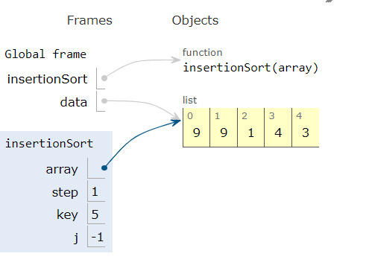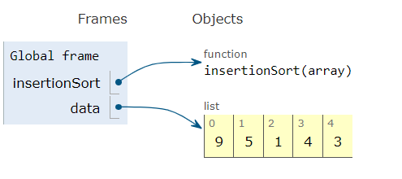**TRACING:**

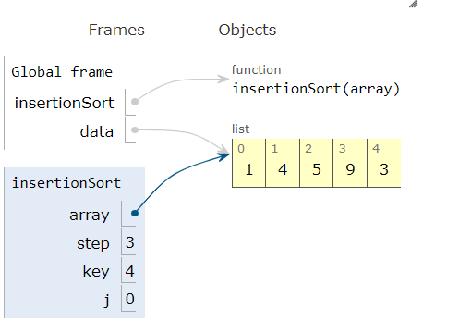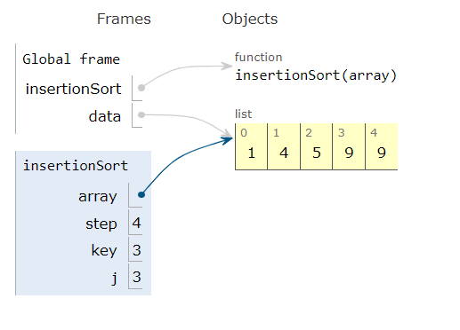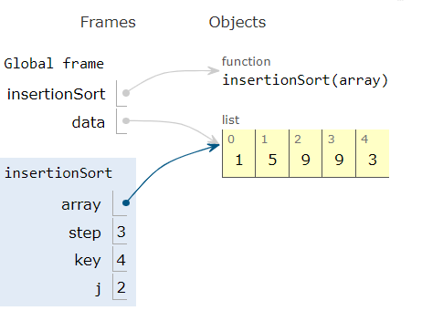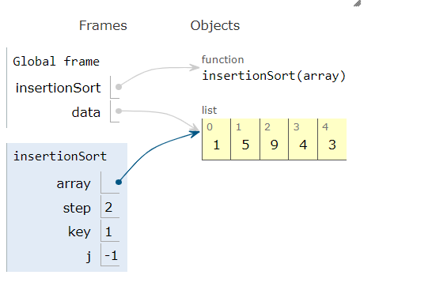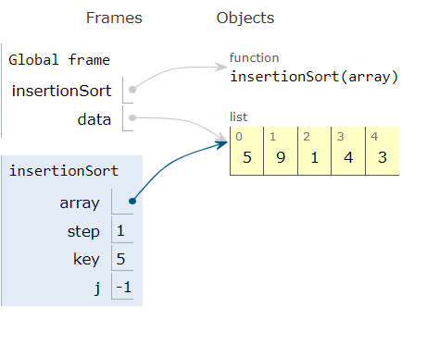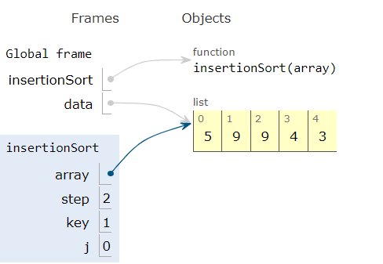

**MERGE SORT:**

def mergeSort(array):

    if len(array) > 1:

        #  r is the point where the array is divided into two subarrays

        r = len(array)//2

        L = array[:r]

        M = array[r:]

        # Sort the two halves

        mergeSort(L)

        mergeSort(M)

        i = j = k = 0

        # Until we reach either end of either L or M, pick larger among

        # elements L and M and place them in the correct position at A[p..r]

        while i < len(L) and j < len(M):

            if L[i] < M[j]:

                array[k] = L[i]

                i += 1

            else:

                array[k] = M[j]

                j += 1

            k += 1

        # When we run out of elements in either L or M,

        # pick up the remaining elements and put in A[p..r]

        while i < len(L):

            array[k] = L[i]

            i += 1

            k += 1

        while j < len(M):

            array[k] = M[j]

            j += 1

            k += 1

# Print the array

def printList(array):

    for i in range(len(array)):

        print(array[i], end=" ")

    print()

# Driver program

if __name__ == '__main__':

    array = [6, 5, 12, 10, 9, 1]

    mergeSort(array)

    print("Sorted array is: ")

    printList(array)

**OUTPUT:**

Sorted array is:

1 5 6 9 10 12

**TRACING:**

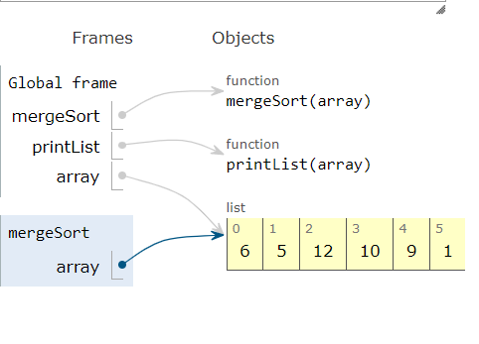 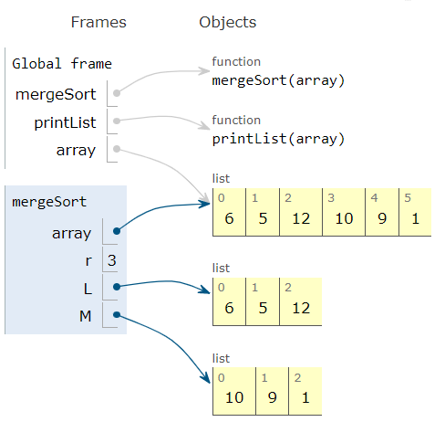

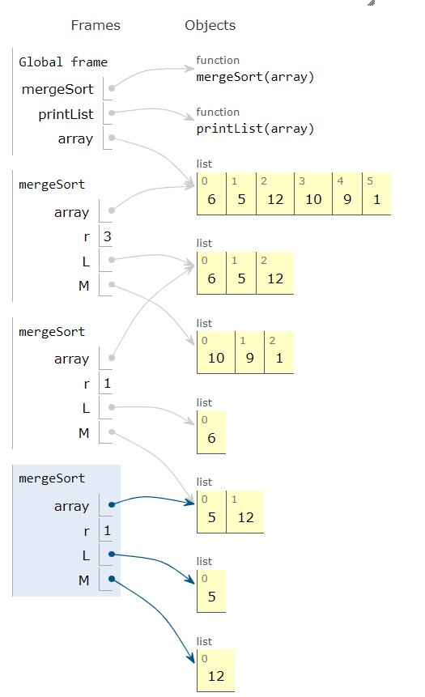 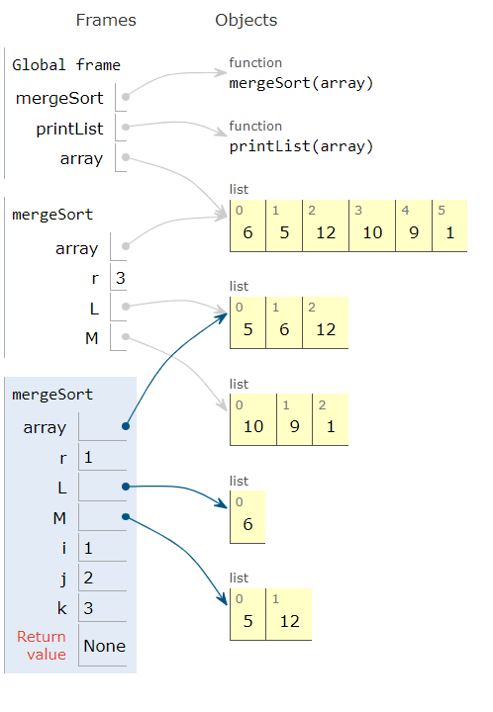

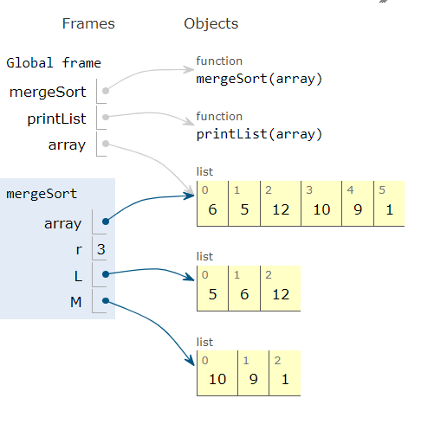 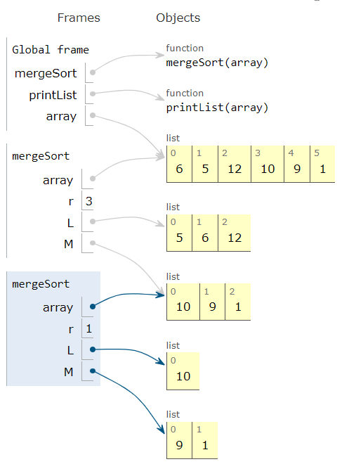

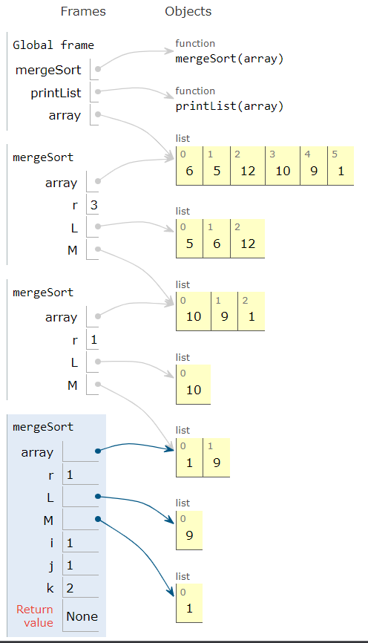 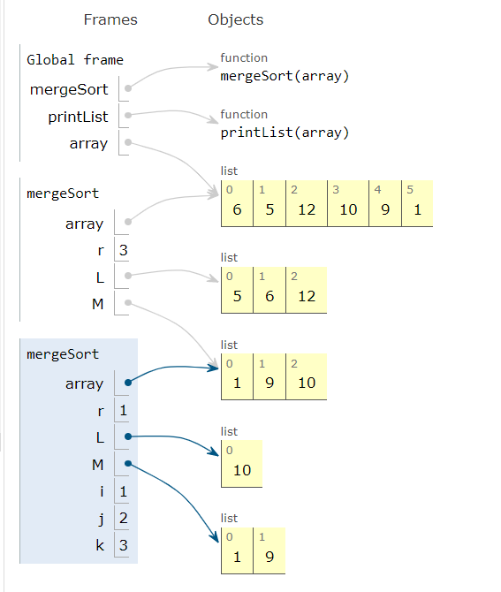

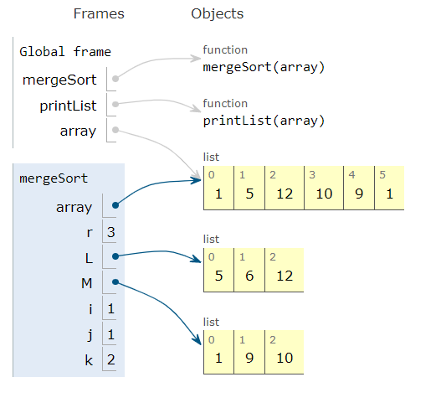 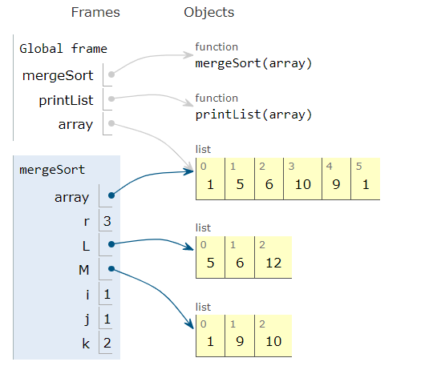

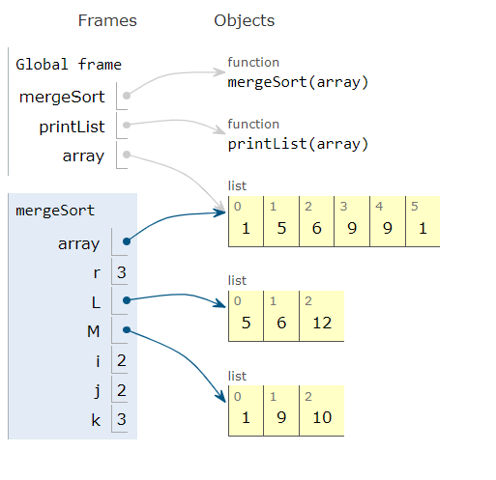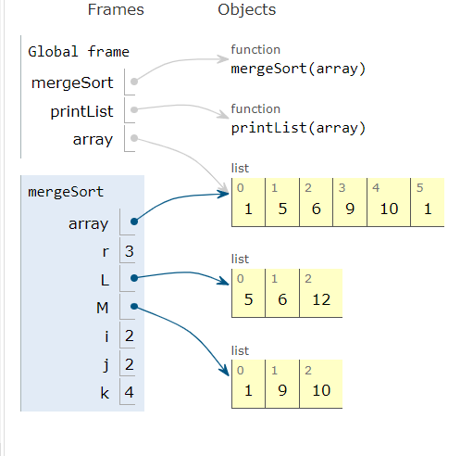

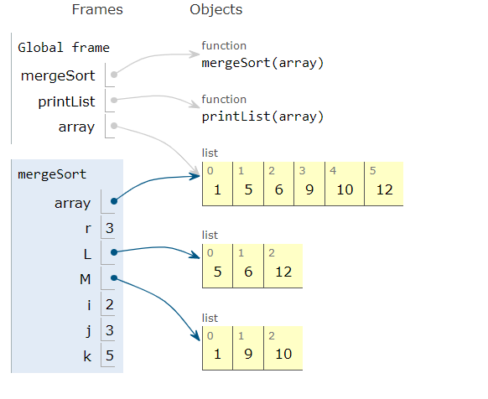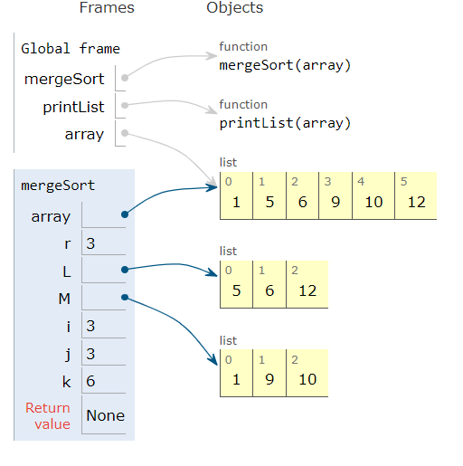

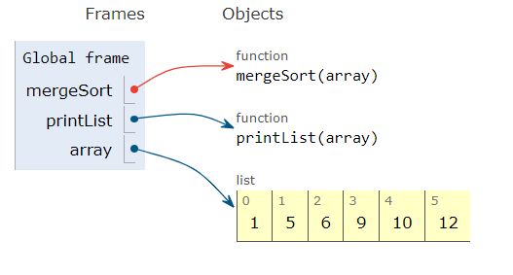

**PROGRAM :**

class Node:

def __init__(self, value):

self.value = value

self.left = None

self.right = None

class BinarySearchTree:

def __init__(self):

self.root = None

def insert(self, value):

new_node = Node(value)

if self.root is None:

self.root = new_node

else:

current_node = self.root

while True:

if current_node.value > value:

if current_node.left is None:

current_node.left = new_node

return

else:

current_node = current_node.left

else:

if current_node.right is None:

current_node.right = new_node

return

else:

current_node = current_node.right

def remove(self, value):

if self.root == None:

return

else:

parent_node = None

current_node = self.root

while current_node:

if current_node.value == value:

break

elif current_node.value > value:

parent_node = current_node

current_node = current_node.left

elif current_node.value < value:

parent_node = current_node

current_node = current_node.right

delete_node = current_node

if parent_node and delete_node:

# deleting the leaf node

if delete_node.right == None and delete_node.left == None:

if parent_node.right == delete_node:

parent_node.right = None

elif parent_node.left == delete_node:

parent_node.left = None

# deleting the one node

elif (delete_node.right == None and delete_node.left) or ( delete_node.left == None and delete_node.right):

final_node = delete_node.right if delete_node.right else delete_node.left

if parent_node.right == delete_node:

parent_node.right = final_node

elif parent_node.left == delete_node:

parent_node.left = final_node

#deleting the two node

elif delete_node:

current_node = delete_node.right while current_node.left:

current_node = current_node.left min_node = current_node replace_value = min_node.value self.remove(replace_value) delete_node.value = replace_value

#deleting the root node

else:

current_node = self.root

right_subtree = current_node.right

min_node = right_subtree

while min_node.left:

min_node = min_node.left

value_replaced = min_node.value

self.remove(value_replaced)

current_node.value = value_replaced

def search(self, value):

curr_node = self.root

while curr_node:

if curr_node.value == value:

return True

elif curr_node.value > value:

if curr_node.left is not None:

curr_node = curr_node.left

else:

return False

elif curr_node.value < value:

if curr_node.right is not None:

curr_node = curr_node.right

else:

return False

def print_tree(tree):

if tree.left:

print_tree(tree.left)

print(tree.value)

if tree.right:

print_tree(tree.right)

tree = BinarySearchTree()

tree.insert(100)

tree.insert(50)

tree.insert(150)

print_tree(“Printing Tree InORDER:”, tree.root)

tree.remove(100)

print(“After removing 100”)

print_tree(“Printing Tree InORDER:”, tree.root)

**OUTPUT:**

Printing Tree InORDER : 50 100 150

Printing after removing 100

Printing Tree INORDER : 50 150

**TRACING:**

Inserting 100

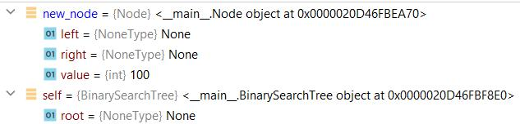

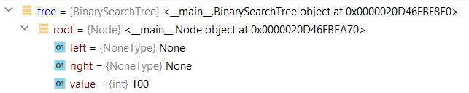

Inserting 50

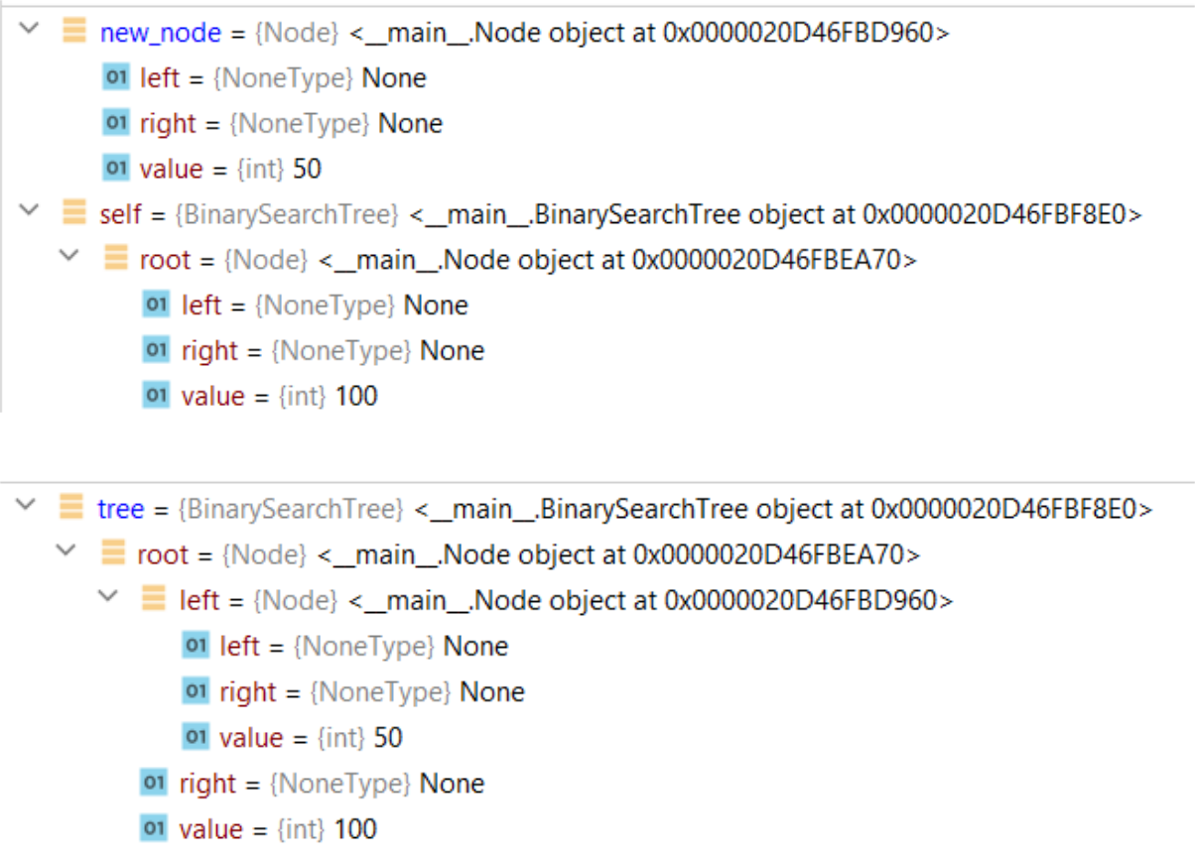

Inserting 150

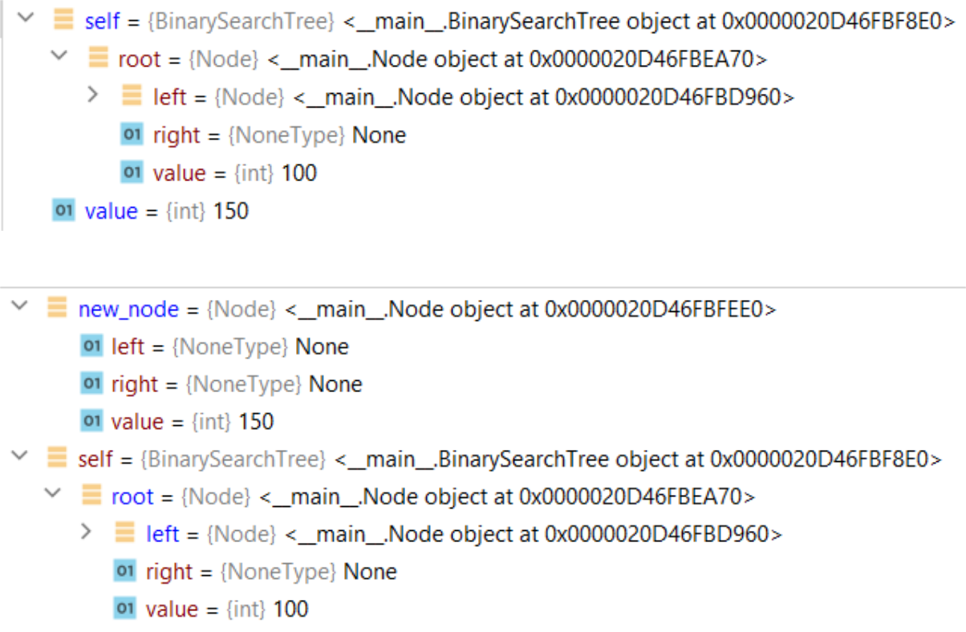

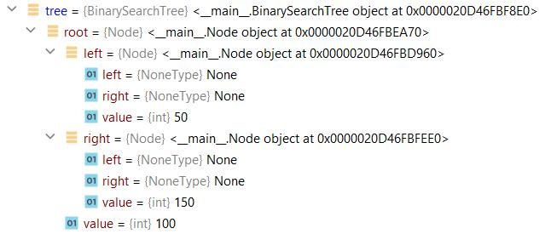

Removing 100 // The node with two children

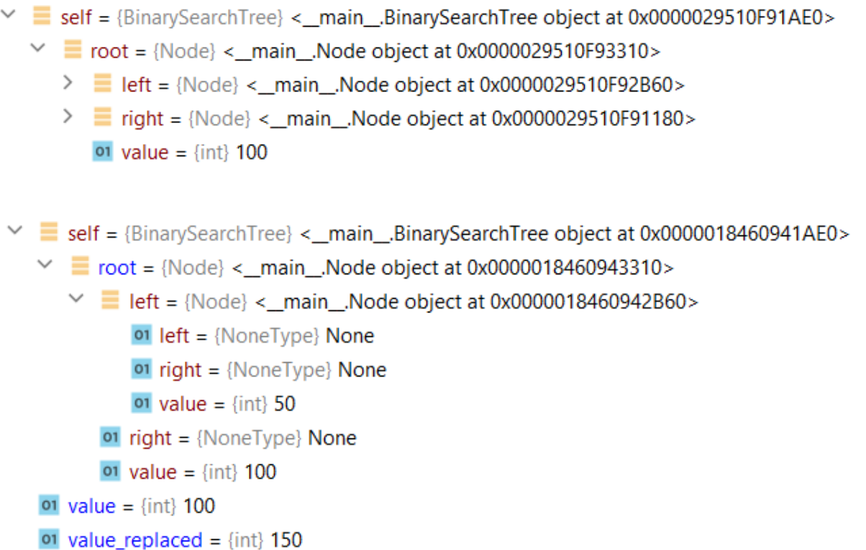

Searching 50

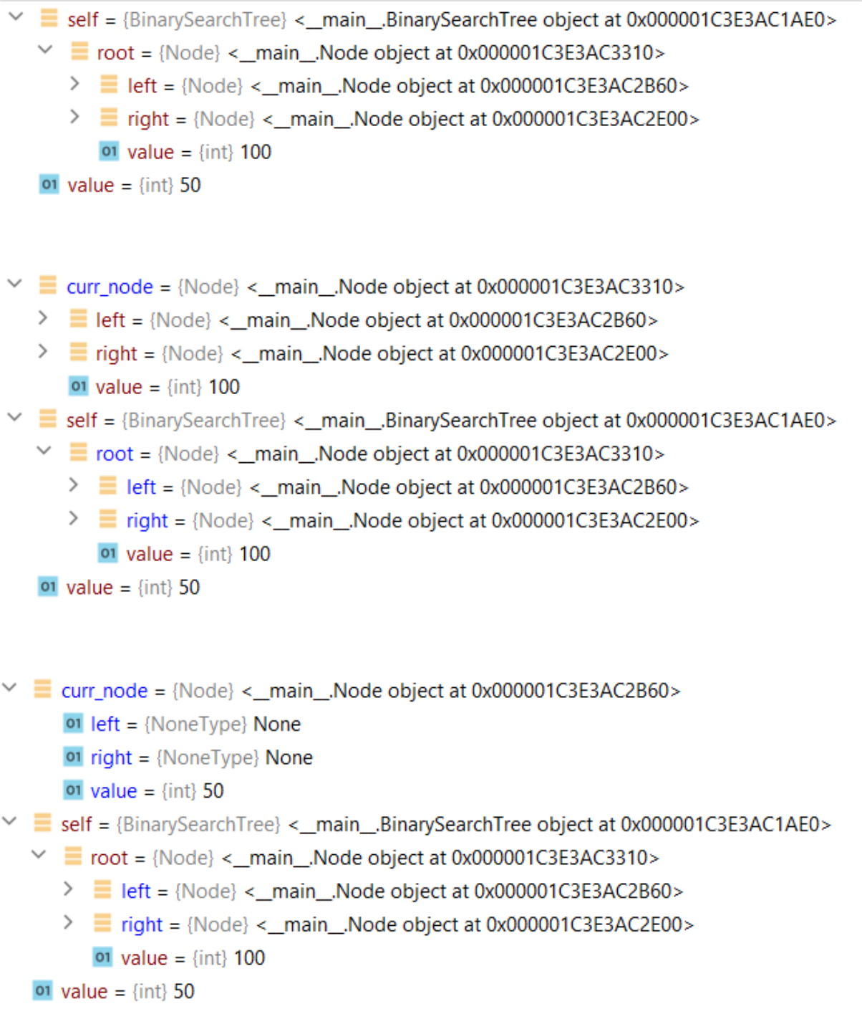

**PROGRAM:**

class MinHeap:

def __init__(self, capacity):

self.storage = [0] * capacity

self.capacity = capacity

self.size = 0

def get_parent_index(self, index):

return (index - 1) // 2

def get_leftchild_index(self, index):

return (2 * index) + 1

def get_rightchild_index(self, index):

return (2 * index) + 2

def has_parent(self, index):

return self.get_parent_index(index) >= 0

def has_leftchild(self, index):

return self.get_leftchild_index(index) < self.size

def has_rightchild(self, index):

return self.get_rightchild_index(index) < self.size

def get_parent(self, index):

return self.storage[self.get_parent_index(index)]

def get_leftchild(self, index):

return self.storage[self.get_leftchild_index(index)]

def get_rightchild(self, index):

return self.storage[self.get_rightchild_index(index)]

def is_full(self):

return self.size == self.capacity

def swap(self, index1, index2):

self.storage[index1], self.storage[index2] = self.storage[index2], self.storage[index1]

def insert(self, value):

if self.is_full():

print("The heap is Full, Try removing some elements!")

else:

self.storage[self.size] = value

self.size += 1

self.heapify_up()

def heapify_up(self):

index = self.size - 1

while self.has_parent(index) and self.get_parent(index) > self.storage[index]:

self.swap(self.get_parent_index(index), index)

index = self.get_parent_index(index)

def remove(self,val):

if self.size == 0:

print("The heap is Empty, Try adding some elements!")

else:

for i in range(self.size):

if val == self.storage[i]:

pos=i

value = self.storage[pos]

self.storage[pos] = self.storage[self.size-1]

self.storage[self.size - 1] = 0

self.size -= 1

self.heapify_down()

def heapify_down(self):

index = 0

while self.has_leftchild(index):

small_value_index = self.get_leftchild_index(index)

if self.has_rightchild(index) and self.get_rightchild(index) < self.get_leftchild(index):

small_value_index = self.get_rightchild_index(index)

if self.storage[index] < self.storage[small_value_index]:

return

else:

self.swap(index, small_value_index)

index = small_value_index

def print_heap(self):

print(self.storage)

min_heap = MinHeap(7)

min_heap.insert(25)

min_heap.insert(56)

min_heap.insert(13)

min_heap.insert(21)

min_heap.insert(24)

print("Before Insertion:")

min_heap.print_heap()

min_heap.insert(16)

print("Average Case Insertion:")

min_heap.print_heap()

min_heap.insert(1)

print("Worst Case Insertion:")

min_heap.print_heap()

print("Average Case Deletion:")

min_heap.remove(21)

min_heap.print_heap()

print("Worst Case Execution:")

min_heap.remove(1)

min_heap.print_heap()

**OUTPUT:**

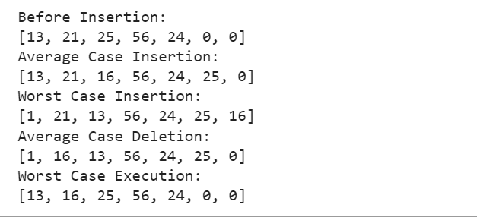

**TRACING:**

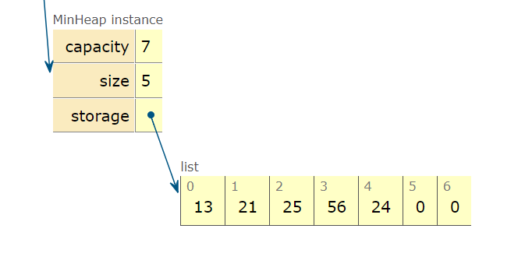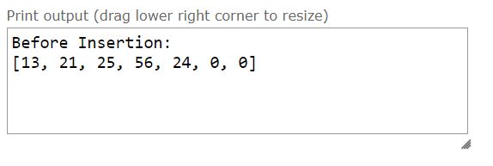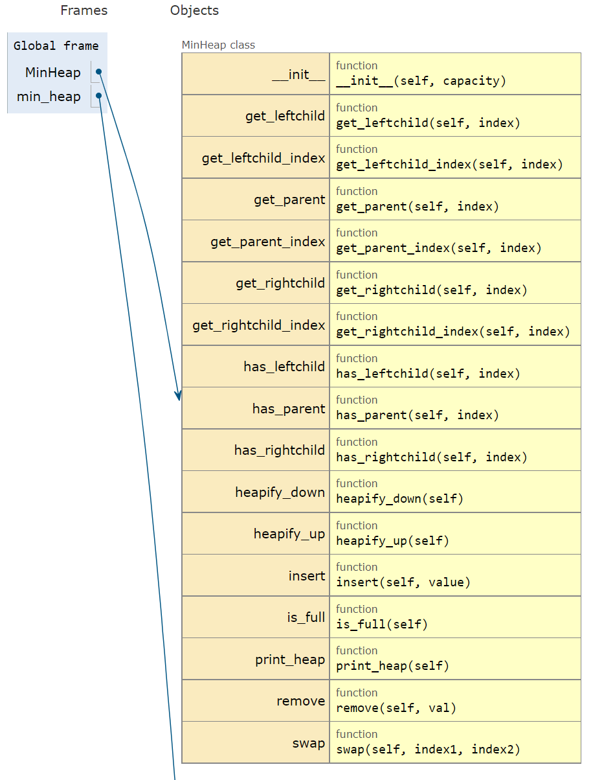

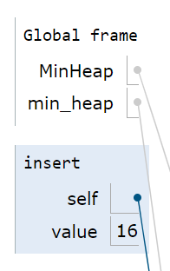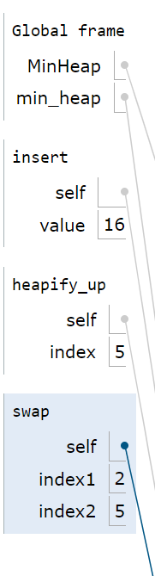INSERT 16 OPERATION:(AVERAGE CASE):

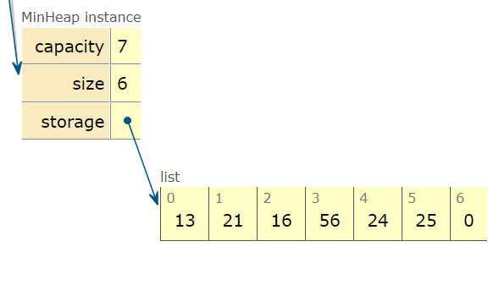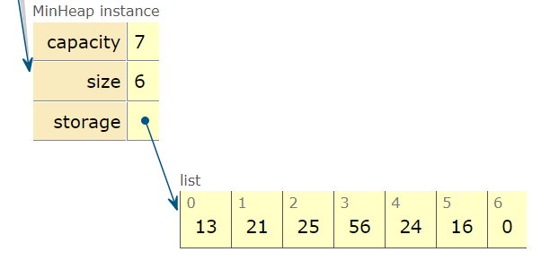

**PROGRAM:**

**PRIM'S ALGORITHM**

INF = 9999999

# number of vertices in graph

V = 5

# create a 2d array of size 5x5

# for adjacency matrix to represent graph

G = [[0, 9, 75, 0, 0],

[9, 0, 95, 19, 42],

[75, 95, 0, 51, 66],

[0, 19, 51, 0, 31],

[0, 42, 66, 31, 0]]

# create a array to track selected vertex

# selected will become true otherwise false

selected = [0, 0, 0, 0, 0]

# set number of edge to 0

no_edge = 0

# the number of egde in minimum spanning tree will be

# always less than(V - 1), where V is number of vertices in

# graph

# choose 0th vertex and make it true

selected[0] = True

# print for edge and weight

print("Edge : Weight\n")

while (no_edge < V - 1):

# For every vertex in the set S, find the all adjacent vertices

#, calculate the distance from the vertex selected at step 1.

# if the vertex is already in the set S, discard it otherwise

# choose another vertex nearest to selected vertex at step 1.

minimum = INF

x = 0

y = 0

for i in range(V):

if selected[i]:

for j in range(V):

if ((not selected[j]) and G[i][j]):

# not in selected and there is an edge

if minimum > G[i][j]:

minimum = G[i][j]

x = i

y = j

print(str(x) + "-" + str(y) + ":" + str(G[x][y]))

selected[y] = True

no_edge += 1

**OUTPUT:**

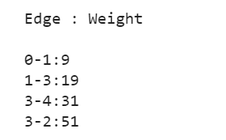

**TRACING:**

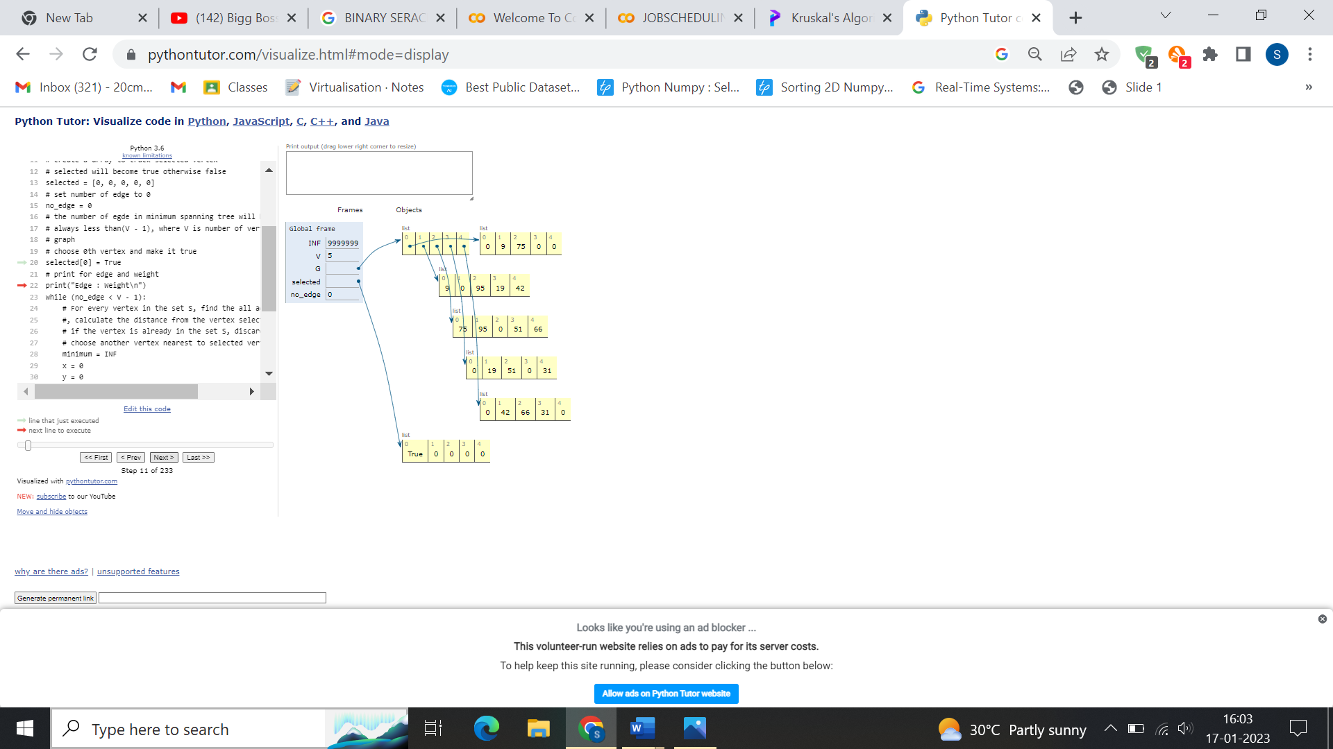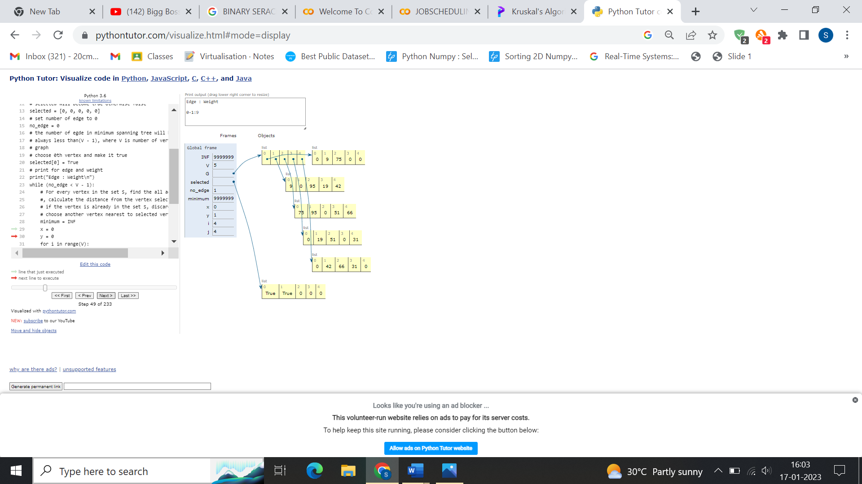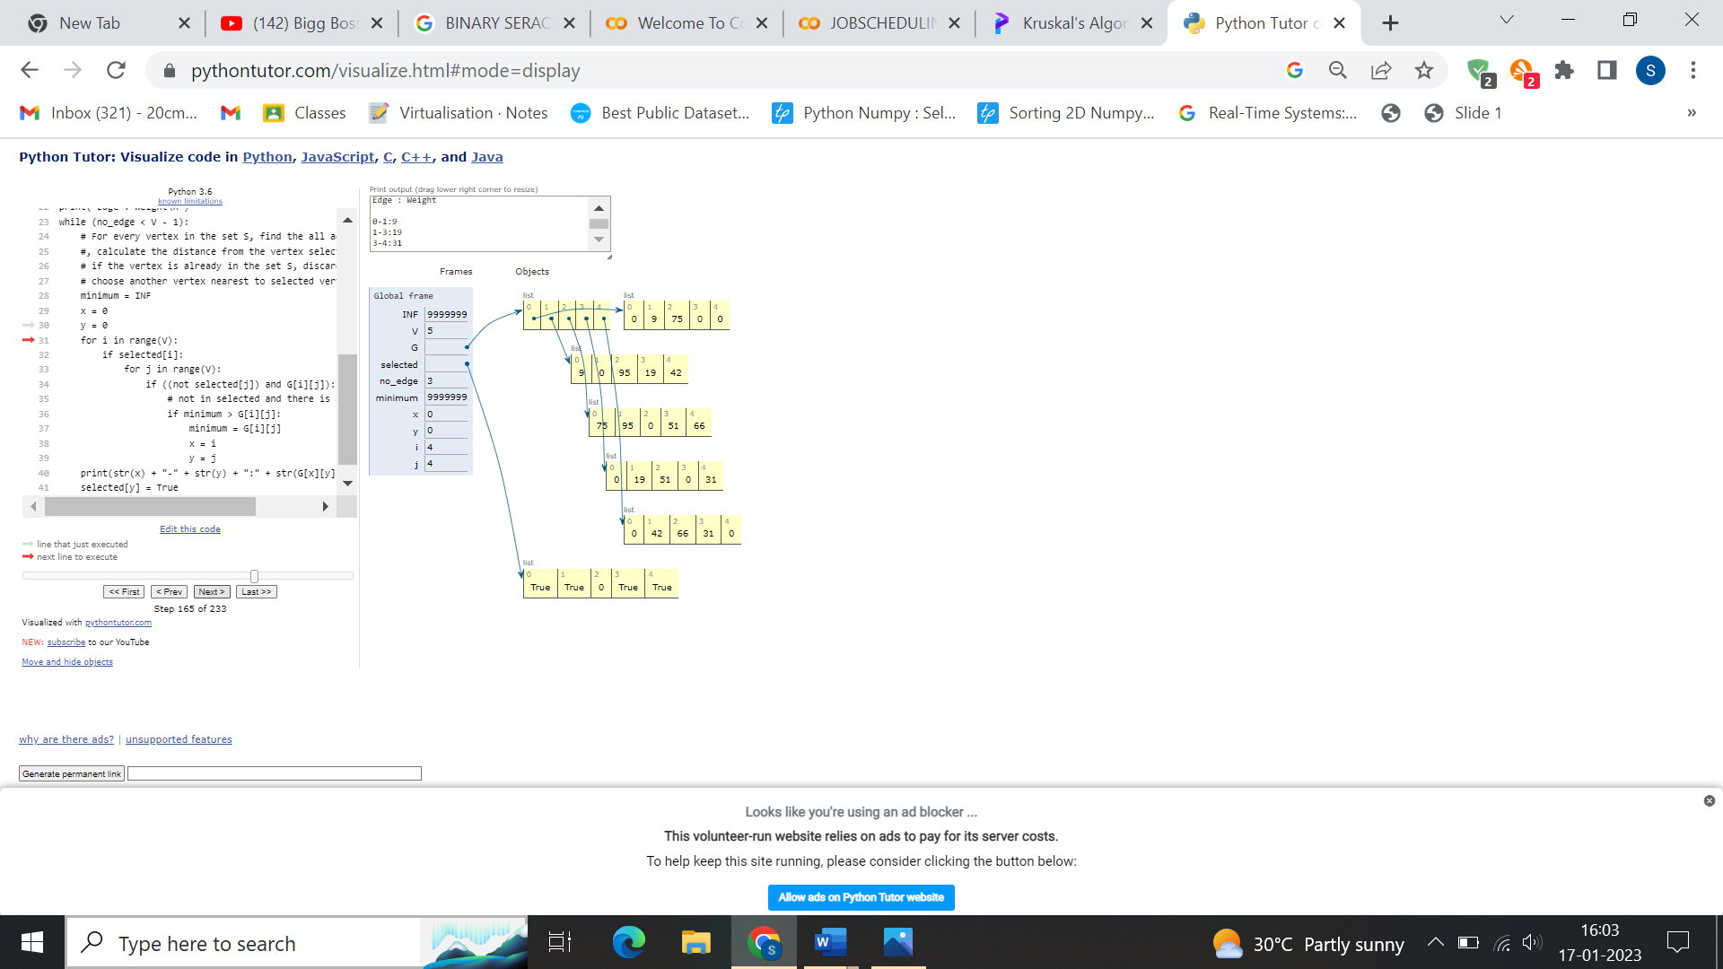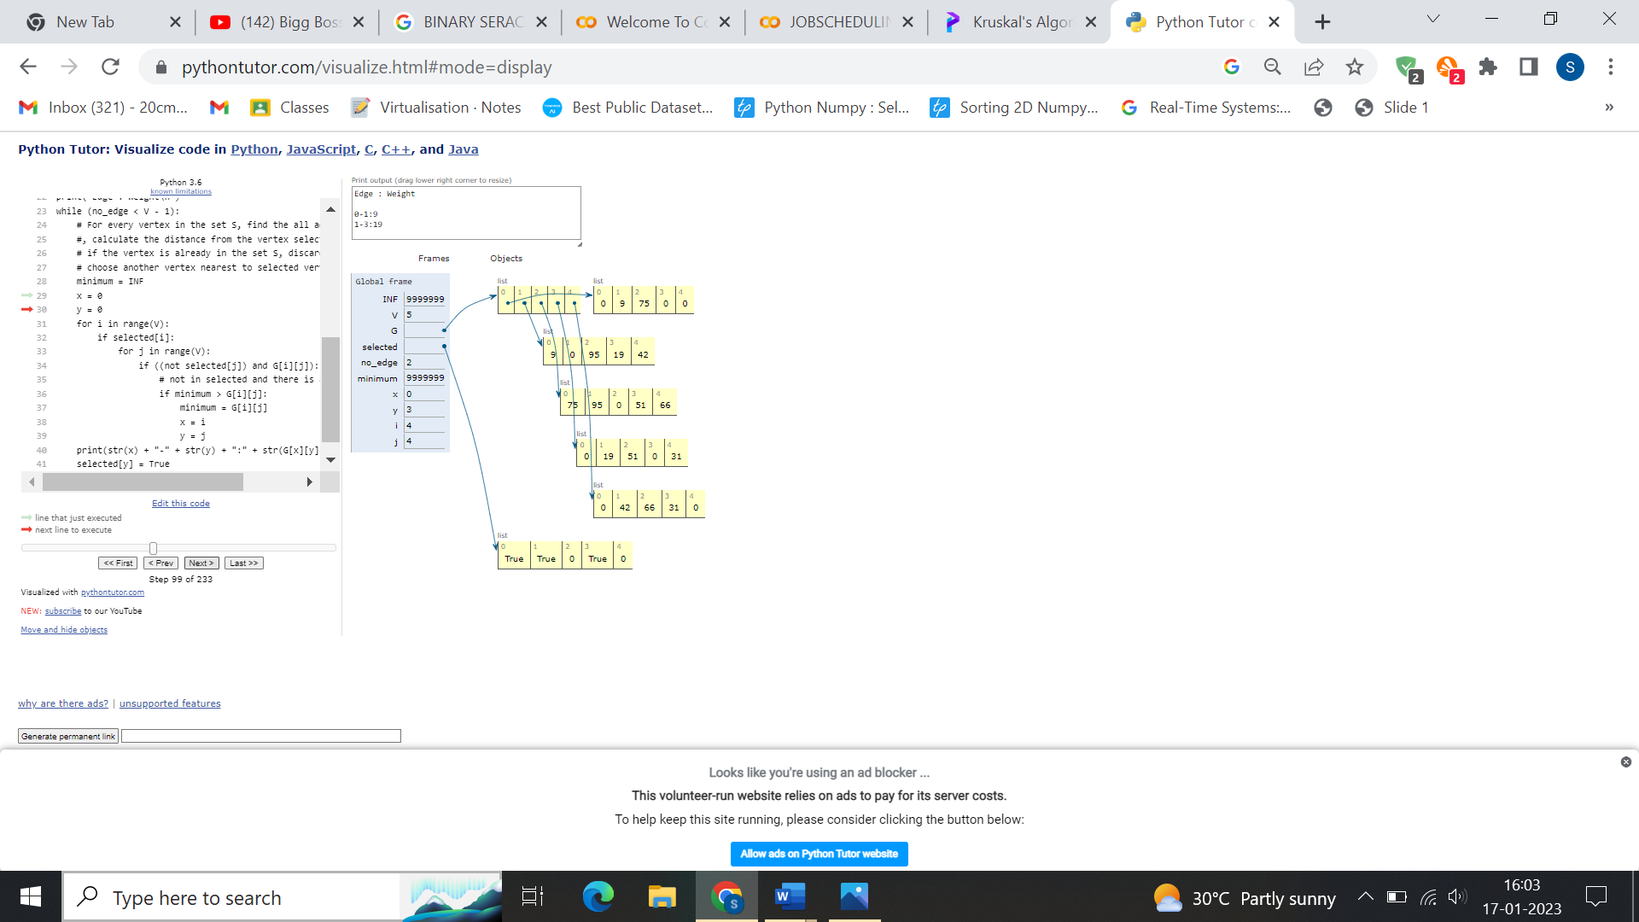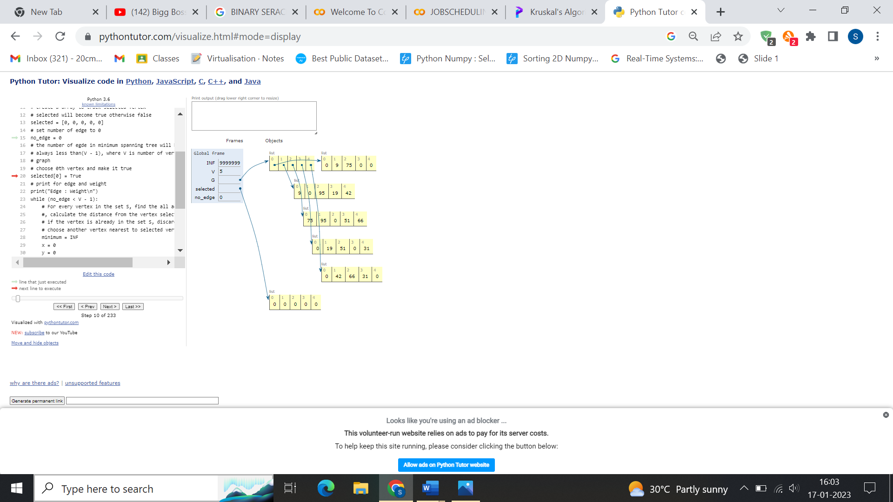

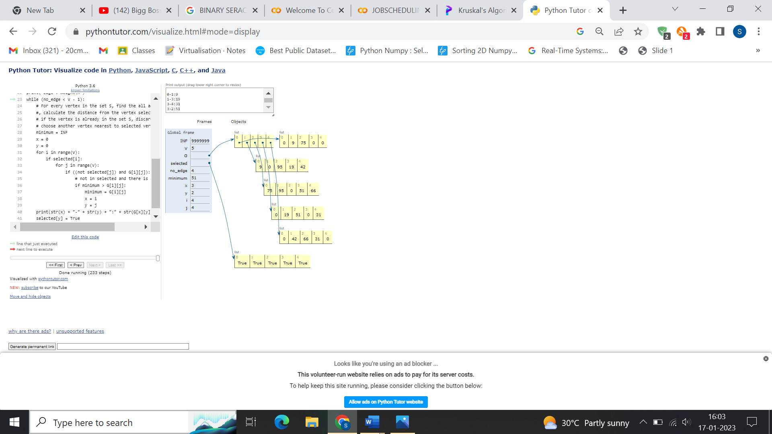

**KRUSKAL’S ALGORITHM**

class Graph:

    def __init__(self, vertices):

        self.V = vertices

        self.graph = []

    def add_edge(self, u, v, w):

        self.graph.append([u, v, w])

    # Search function

    def find(self, parent, i):

        if parent[i] == i:

            return i

        return self.find(parent, parent[i])

    def apply_union(self, parent, rank, x, y):

        xroot = self.find(parent, x)

        yroot = self.find(parent, y)

        if rank[xroot] < rank[yroot]:

            parent[xroot] = yroot

        elif rank[xroot] > rank[yroot]:

            parent[yroot] = xroot

        else:

            parent[yroot] = xroot

            rank[xroot] += 1

    #  Applying Kruskal algorithm

    def kruskal_algo(self):

        result = []

        i, e = 0, 0

        self.graph = sorted(self.graph, key=lambda item: item[2])

        parent = []

        rank = []

        for node in range(self.V):

            parent.append(node)

            rank.append(0)

        while e < self.V - 1:

            u, v, w = self.graph[i]

            i = i + 1

            x = self.find(parent, u)

            y = self.find(parent, v)

            if x != y:

                e = e + 1

                result.append([u, v, w])

                self.apply_union(parent, rank, x, y)

        for u, v, weight in result:

            print("%d - %d: %d" % (u, v, weight))

g = Graph(6)

g.add_edge(0, 1, 4)

g.add_edge(0, 2, 4)

g.add_edge(1, 2, 2)

g.add_edge(1, 0, 4)

g.add_edge(2, 0, 4)

g.add_edge(2, 1, 2)

g.add_edge(2, 3, 3)

g.add_edge(2, 5, 2)

g.add_edge(2, 4, 4)

g.add_edge(3, 2, 3)

g.add_edge(3, 4, 3)

g.add_edge(4, 2, 4)

g.add_edge(4, 3, 3)

g.add_edge(5, 2, 2)

g.add_edge(5, 4, 3)

g.kruskal_algo()

**OUTPUT:**

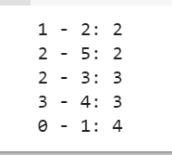

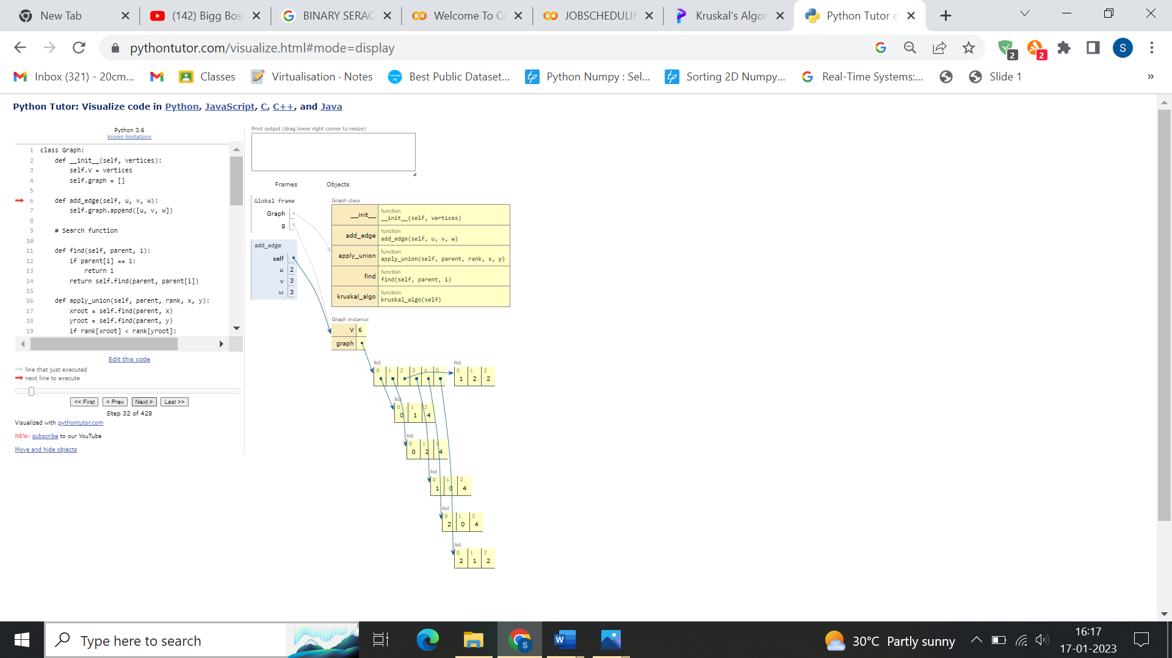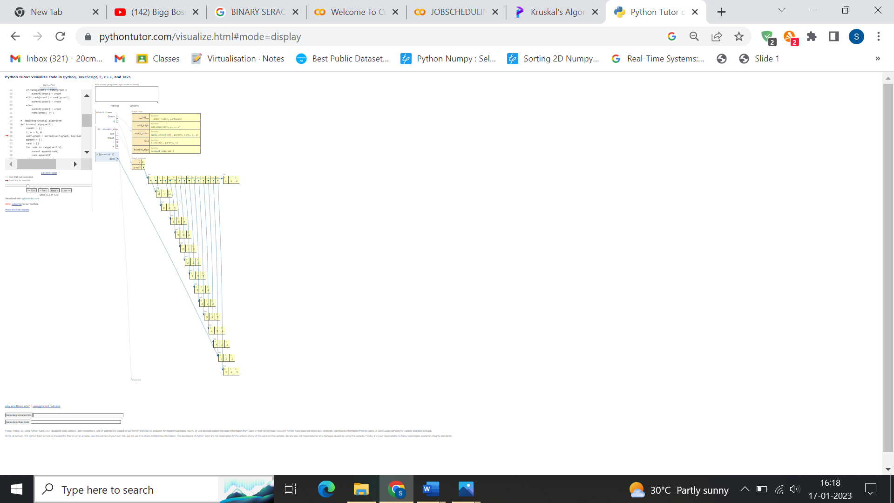**TRACING:**

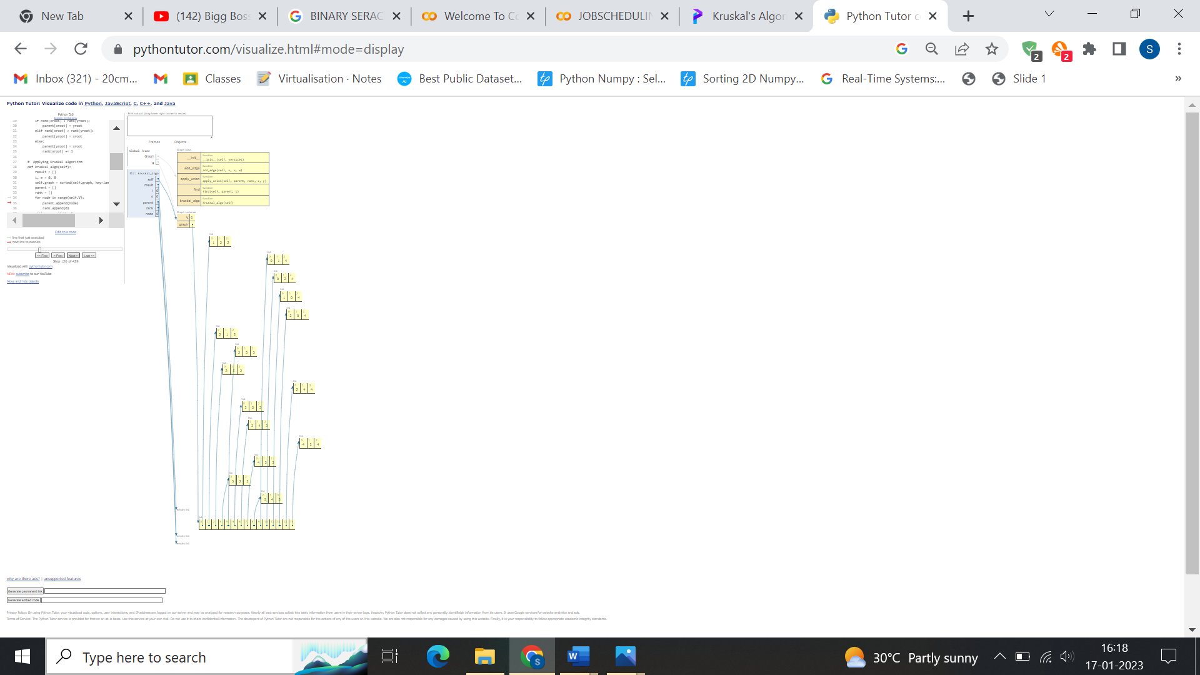

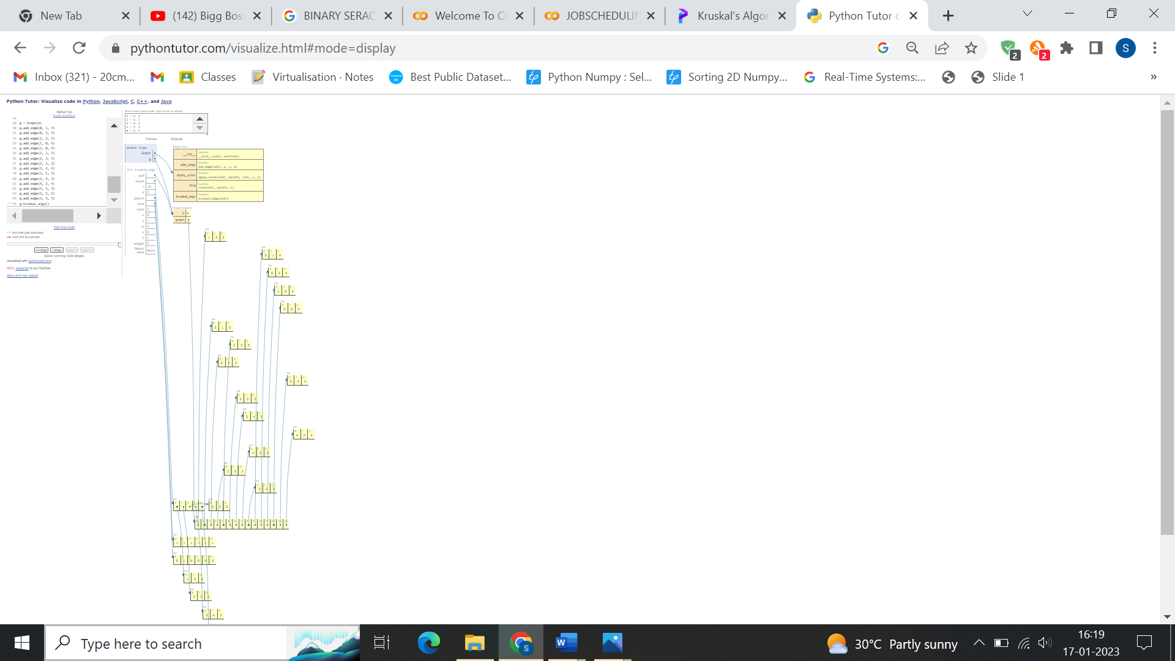

**PROGRAM:**

def job_scheduling_algo(activities, start, end):

  for i in range(0, len(end) - 1):

    for j in range(i + 1, len(end)):

      if end[i] > end[j]:

        activities[i], activities[j] = activities[j], activities[i]

        start[i], start[j] = start[j], start[i]

        end[i], end[j] = end[j], end[i]

  # print(activities, start, end)

  index = 0

  value = 0

  result_list = []

  while index < len(activities):

    current_activity = activities[index]

    current_start = start[index]

    current_end = end[index]

    # print(current_activity, current_start, current_end)

    if current_start >= value:

      result_list.append(current_activity)

      value = current_end

    index += 1

  print(result_list)

job_scheduling_algo(["A1", "A2", "A3", "A4", "A5", "A6"], [0, 3, 1, 5, 5, 8], [6, 4, 2, 9, 7, 9])

**OUTPUT:**

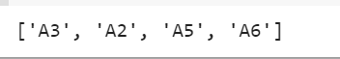

**TRACING:**

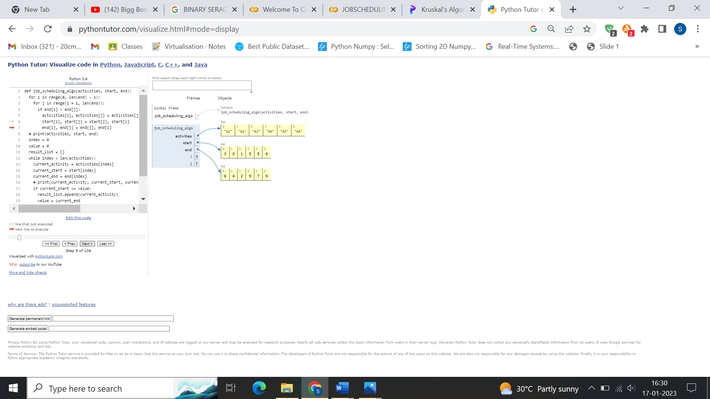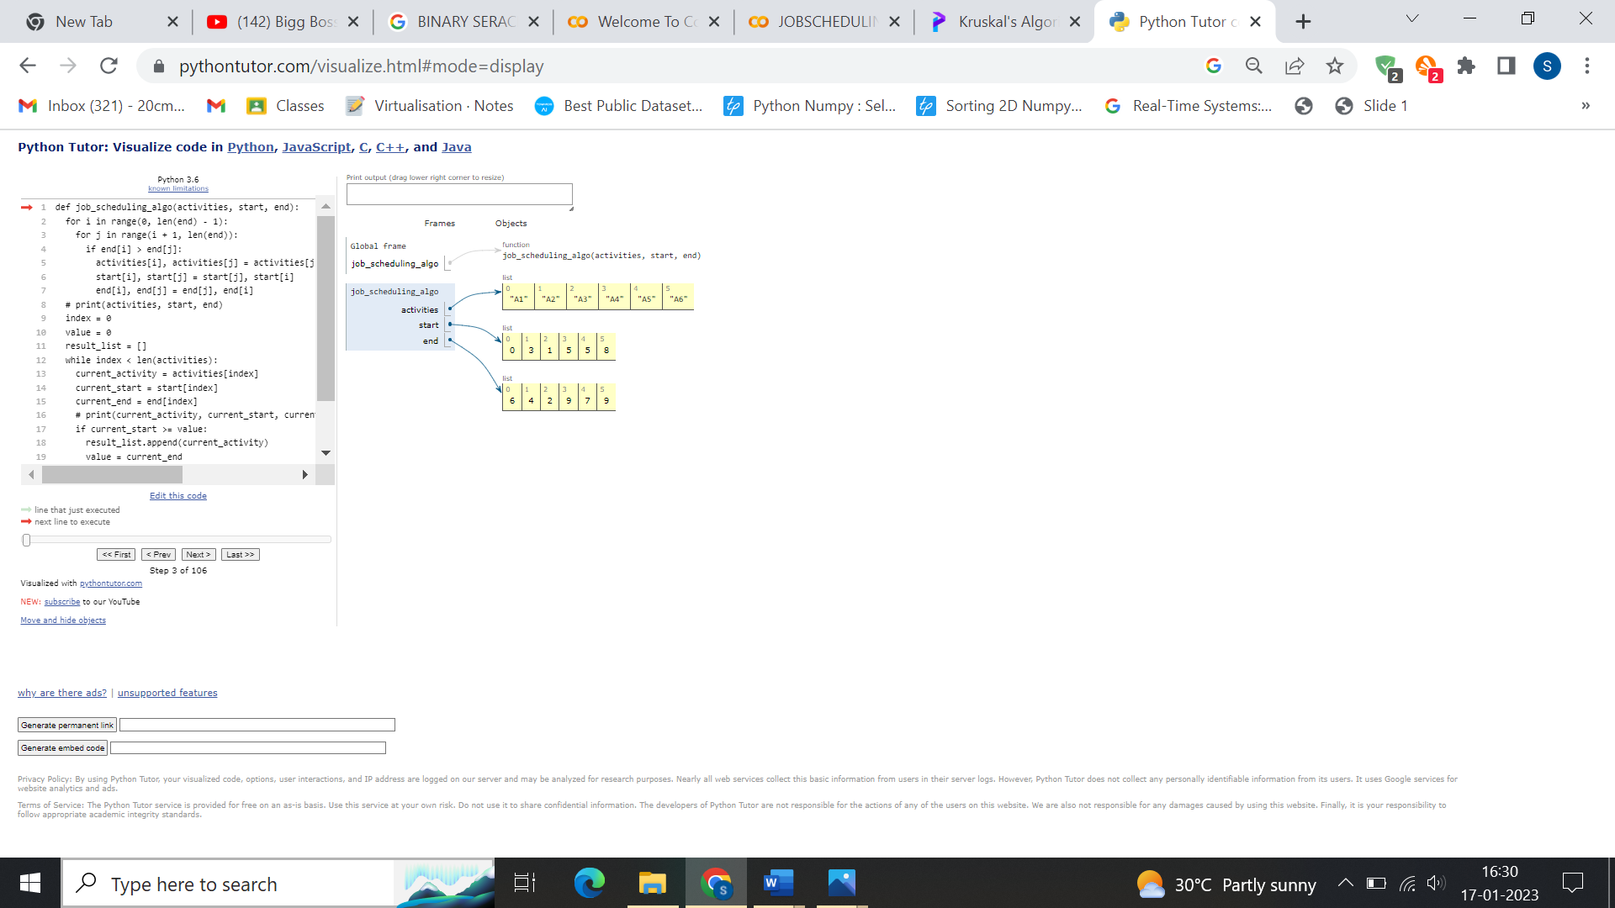

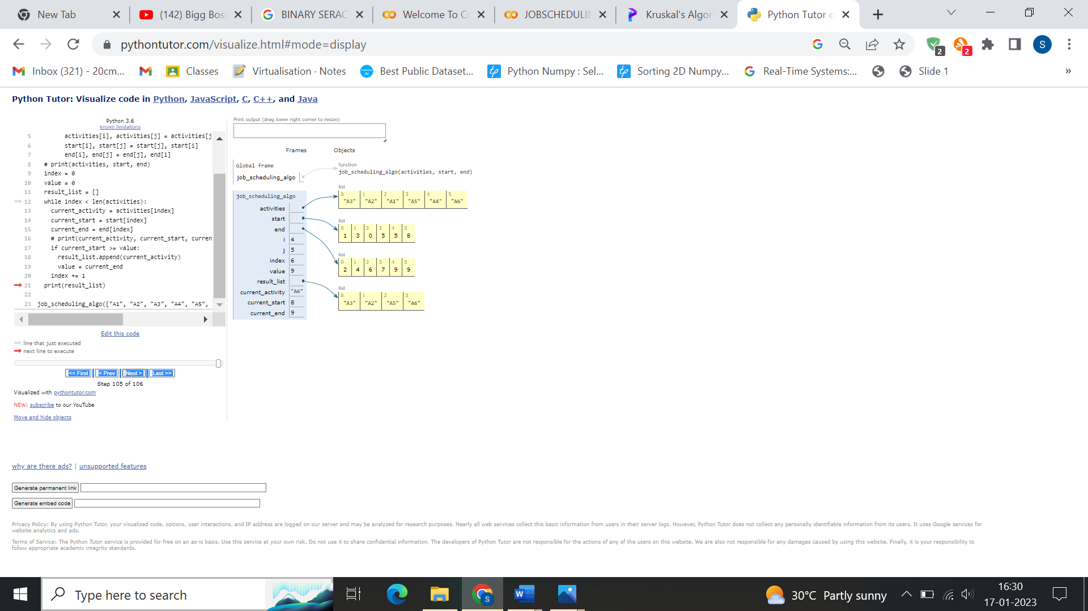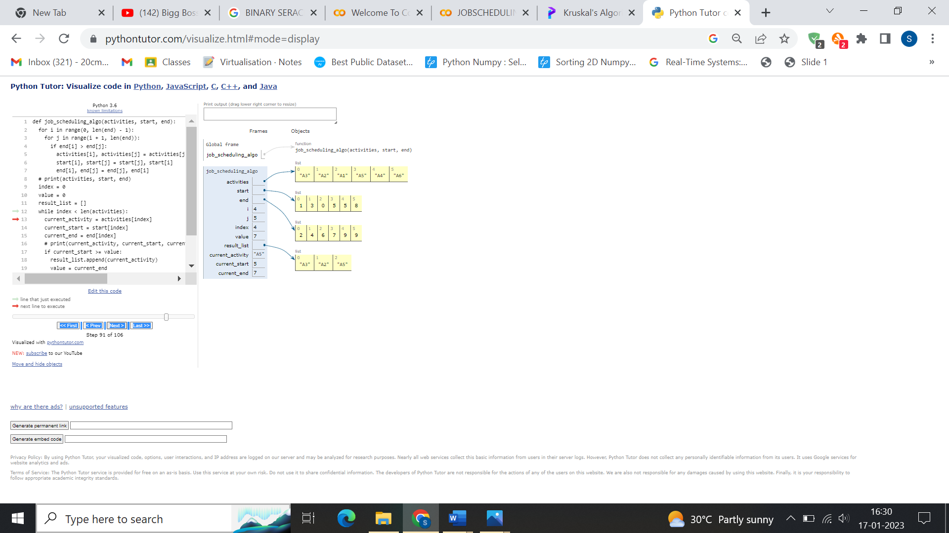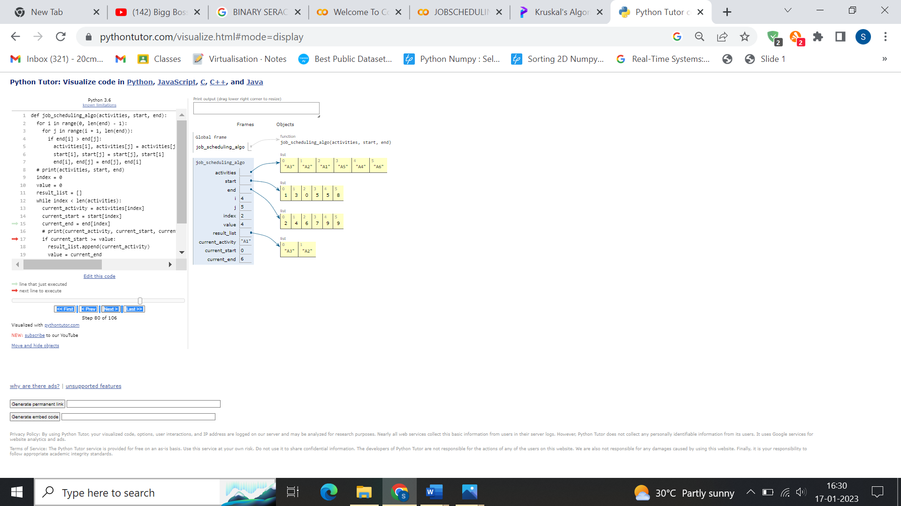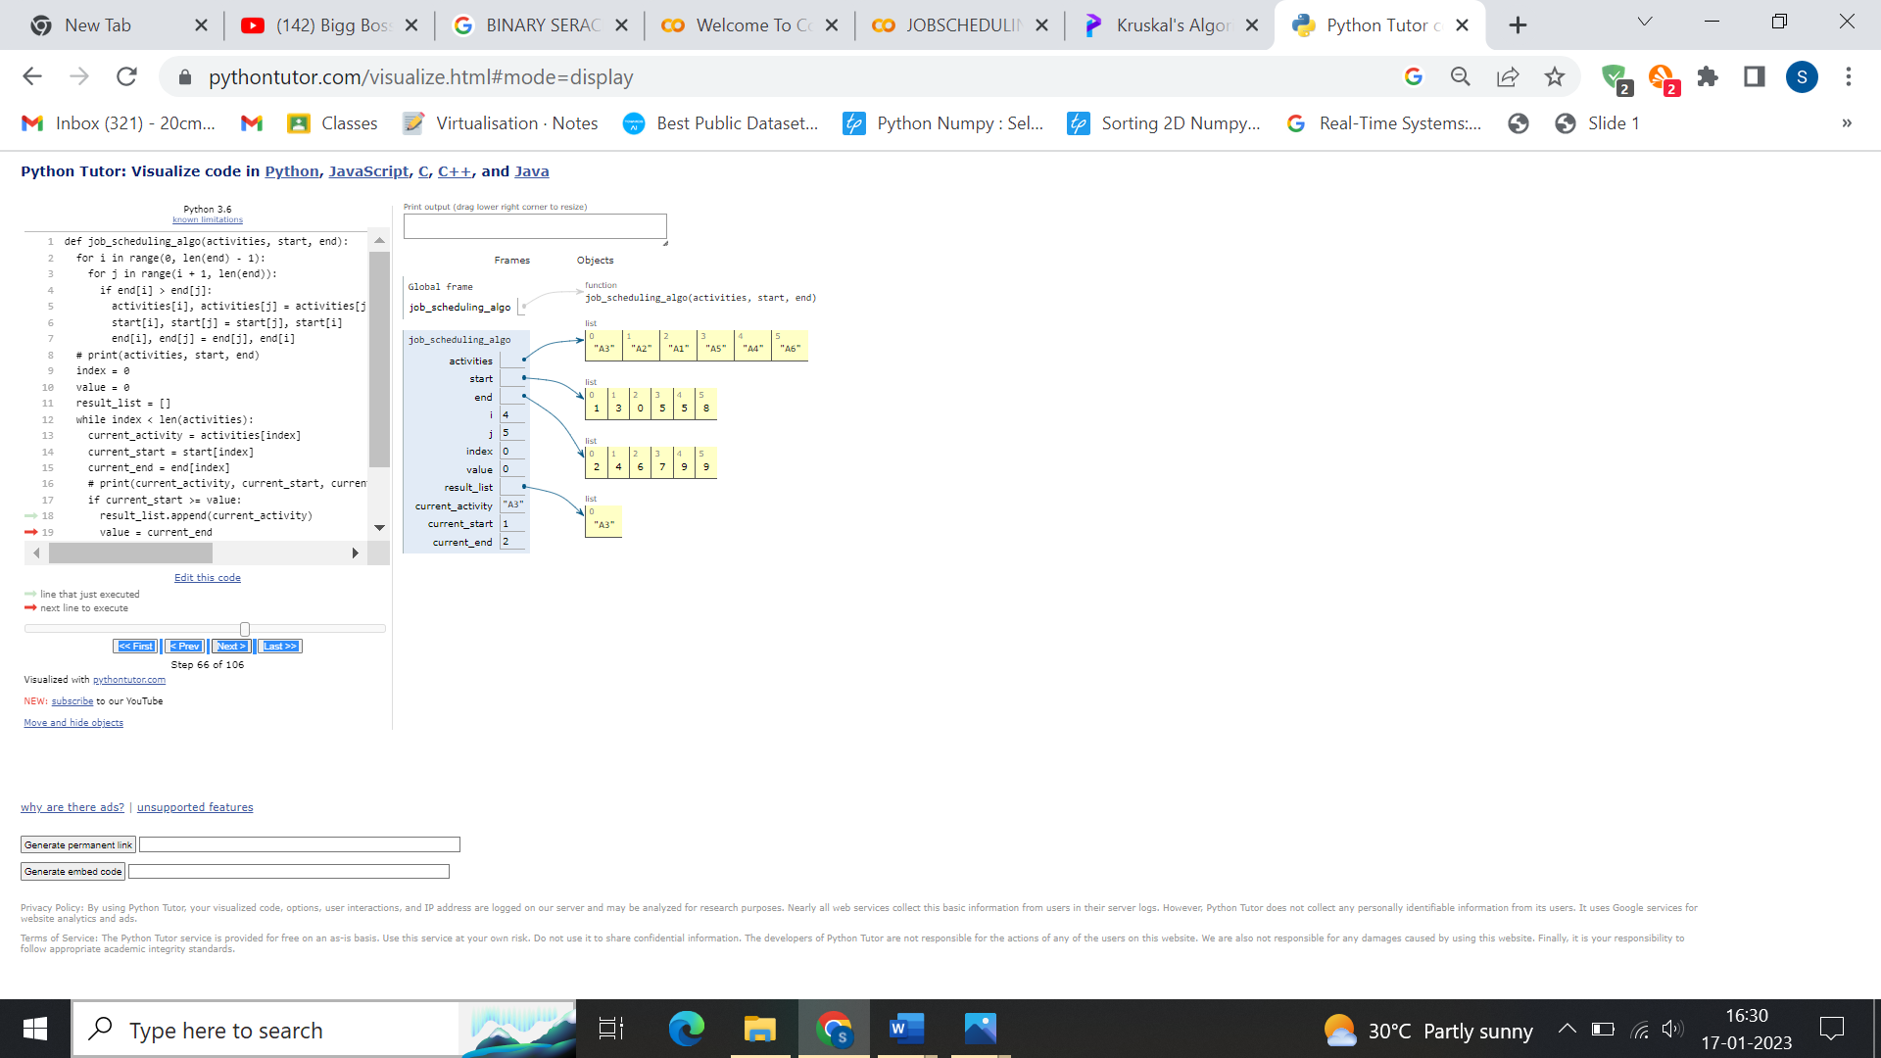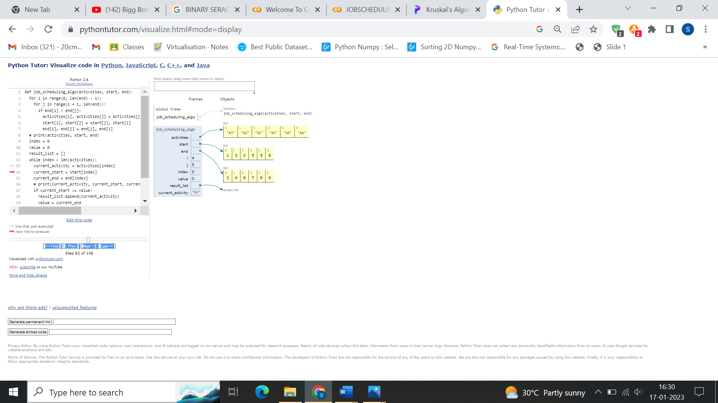**PROGRAM:**

global N

N = int(input("Enter the number of queens:"))

def printSolution(board):

    for i in range(N):

        for j in range(N):

            print (board[i][j],end=' ')

        print()

def isSafe(board, row, col):

    for i in range(col):

        if board[row][i] == 1:

            return False

    for i, j in zip(range(row, -1, -1), range(col, -1, -1)):

        if board[i][j] == 1:

            return False

    for i, j in zip(range(row, N, 1), range(col, -1, -1)):

        if board[i][j] == 1:

            return False

    return True

def solveNQUtil(board, col):

    if col >= N:

        return True

    for i in range(N):

        if isSafe(board, i, col):

            board[i][col] = 1

            if solveNQUtil(board, col + 1) == True:

                return True

            board[i][col] = 0

    return False

def solveNQ():

    board = [[0]*N for _ in range(N)]

    if solveNQUtil(board, 0) == False:

        print ("Solution does not exist")

        return

    printSolution(board)

    return

solveNQ()

**OUTPUT:**

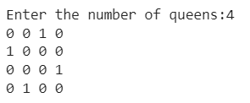

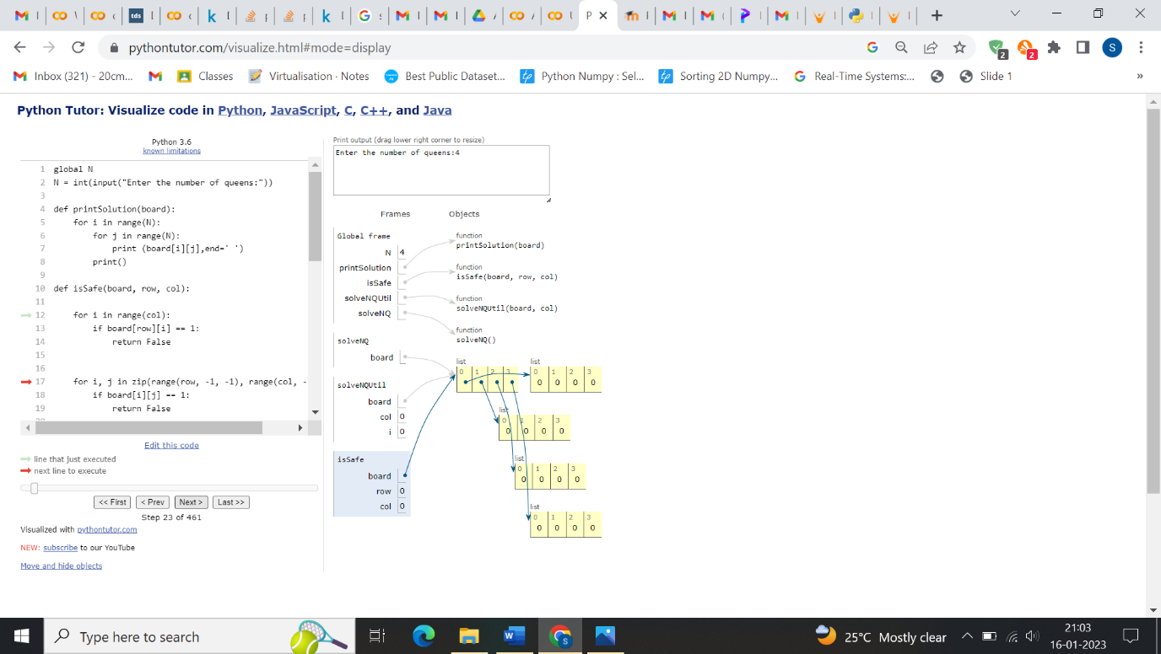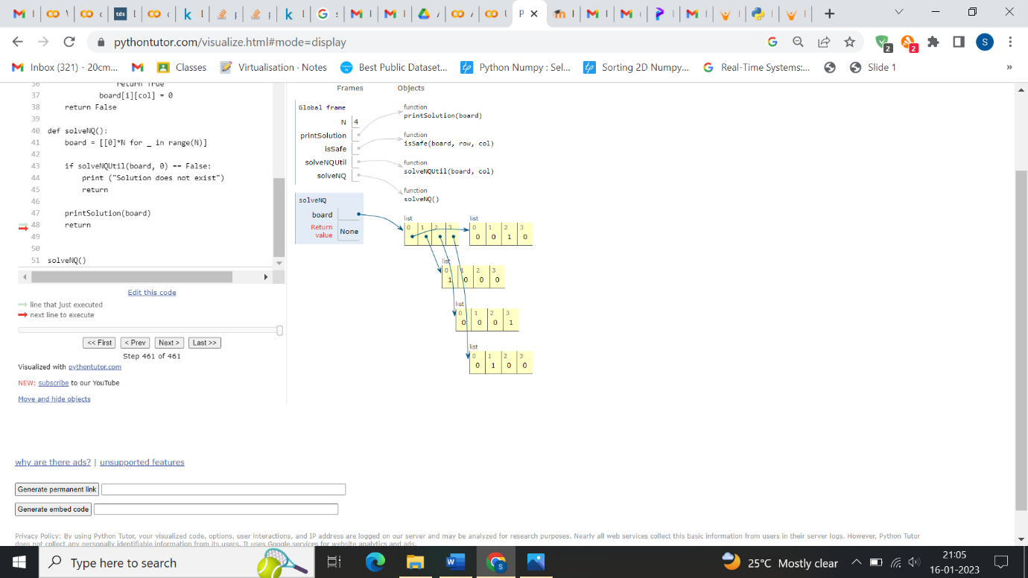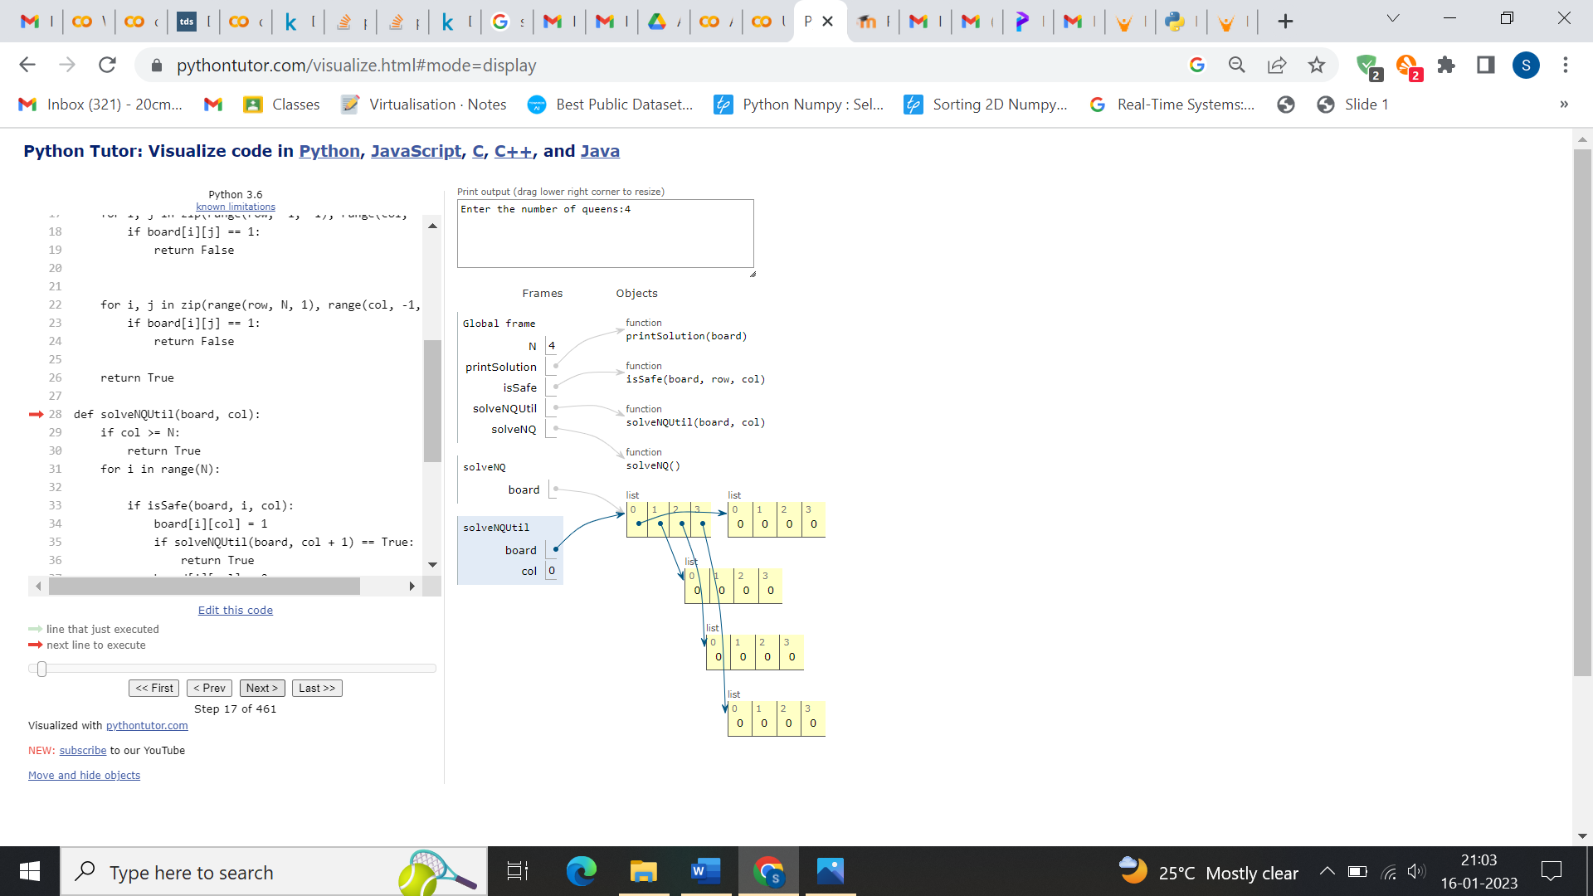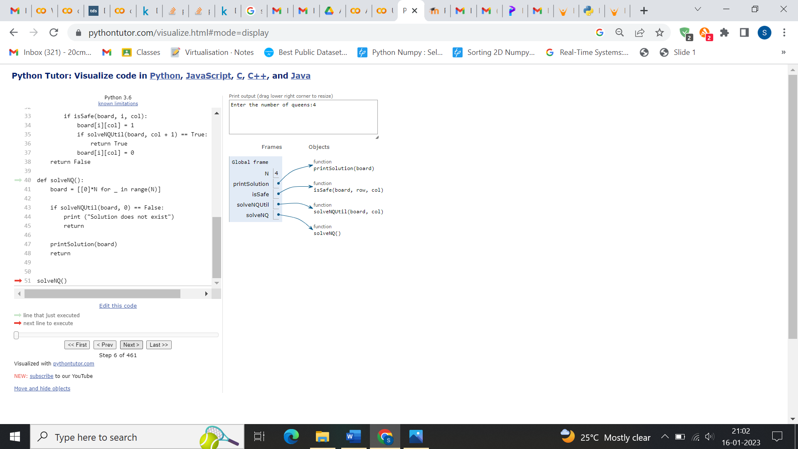**TRACING:**

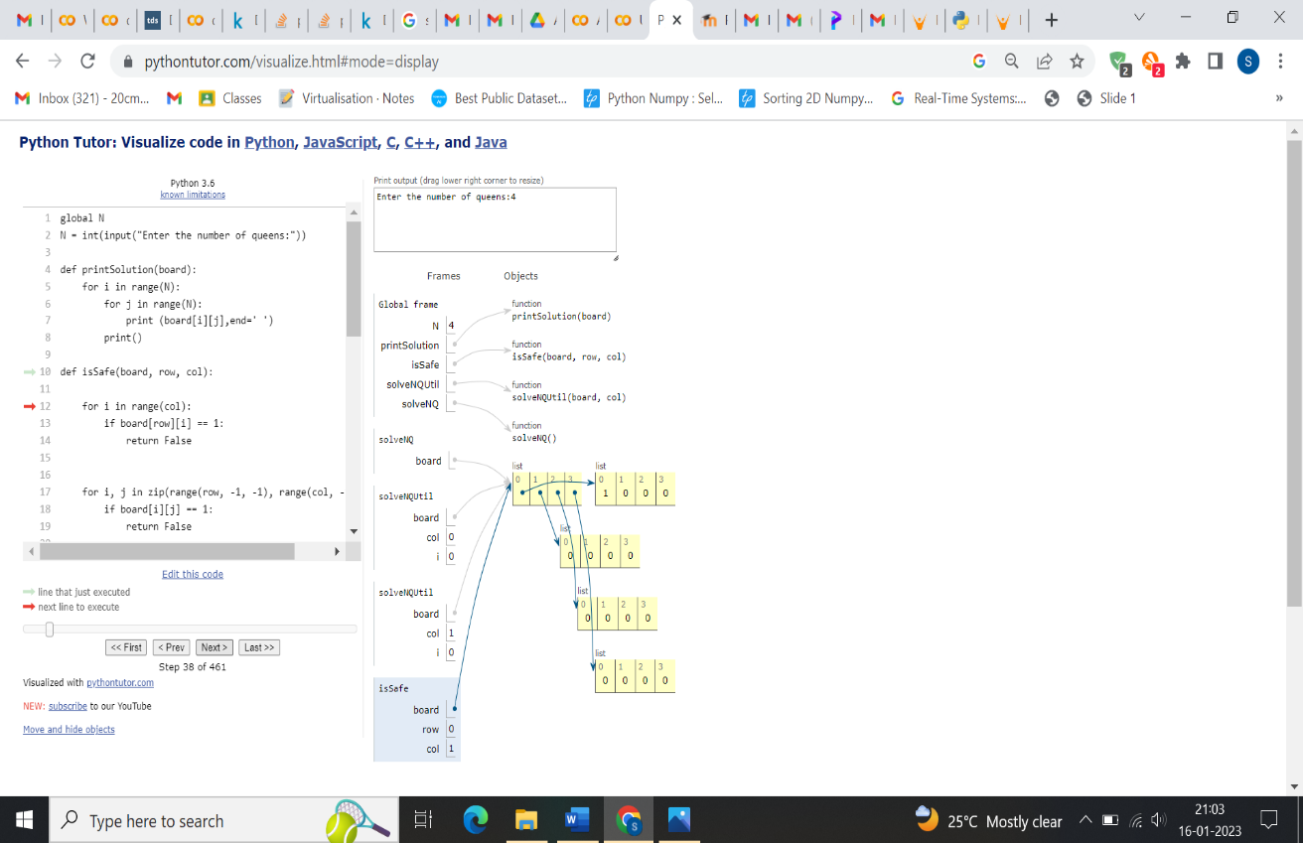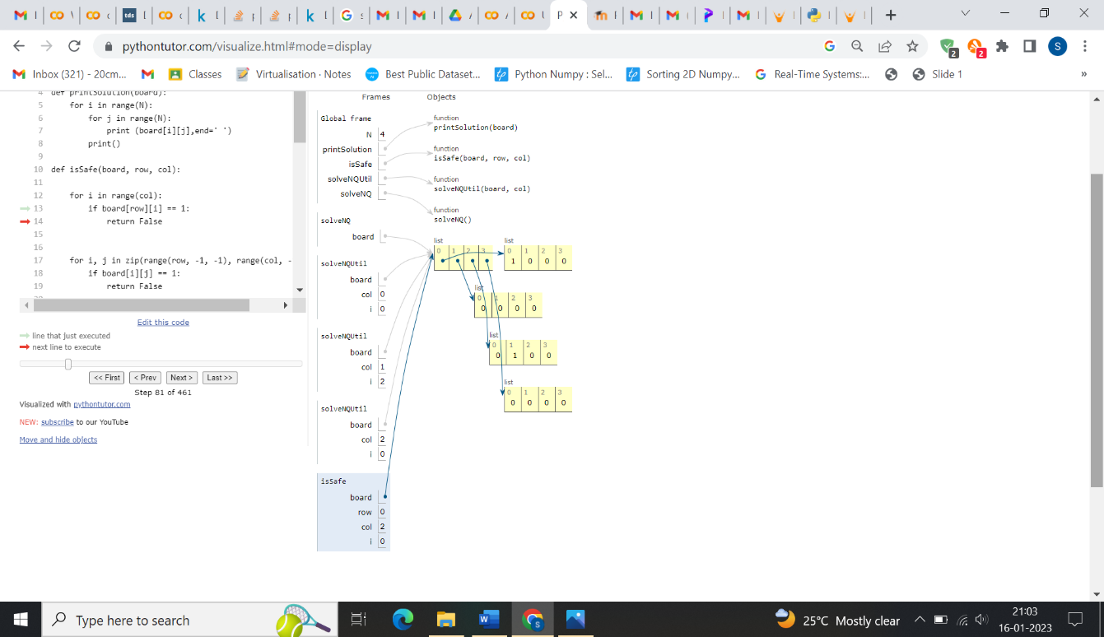

**LONGEST COMMON SUBSEQUENCE PROBLEM**

def lcs_algo(S1, S2, m, n):

L = [[0 for x in range(n+1)] for x in range(m+1)]

# Building the mtrix in bottom-up way

for i in range(m+1):

for j in range(n+1):

if i == 0 or j == 0:

L[i][j] = 0

elif S1[i-1] == S2[j-1]:

L[i][j] = L[i-1][j-1] + 1

else:

L[i][j] = max(L[i-1][j], L[i][j-1])

index = L[m][n]

lcs_algo = [""] * (index+1)

lcs_algo[index] = ""

i = m

j = n

while i > 0 and j > 0:

if S1[i-1] == S2[j-1]:

lcs_algo[index-1] = S1[i-1]

i -= 1

j -= 1

index -= 1

elif L[i-1][j] > L[i][j-1]:

i -= 1

else:

j -= 1

# Printing the sub sequences

print("S1 : " + S1 + "\nS2 : " + S2)

print("LCS: " + "".join(lcs_algo))

S1 = "ACADB"

S2 = "CBDA"

m = len(S1)

n = len(S2)

lcs_algo(S1, S2, m, n)

**OUTPUT:**

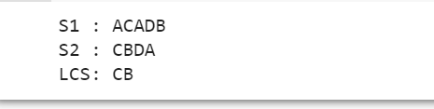

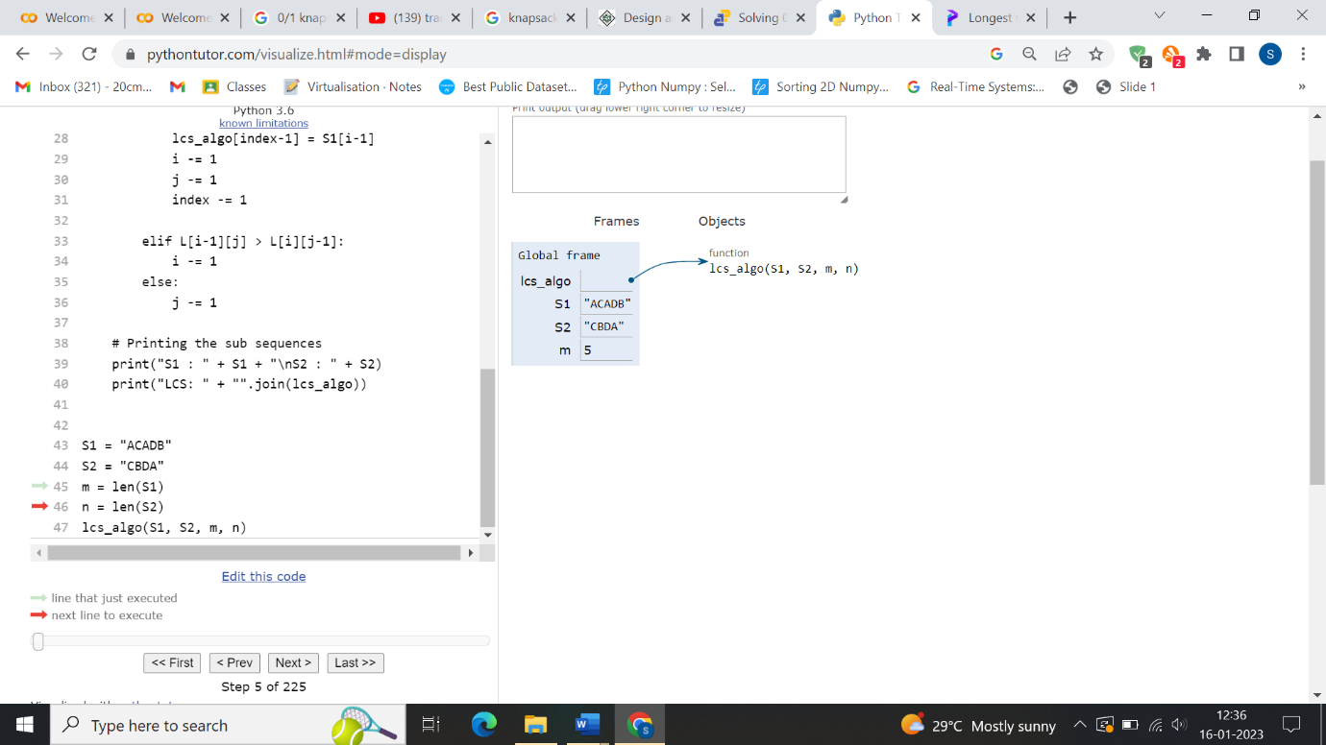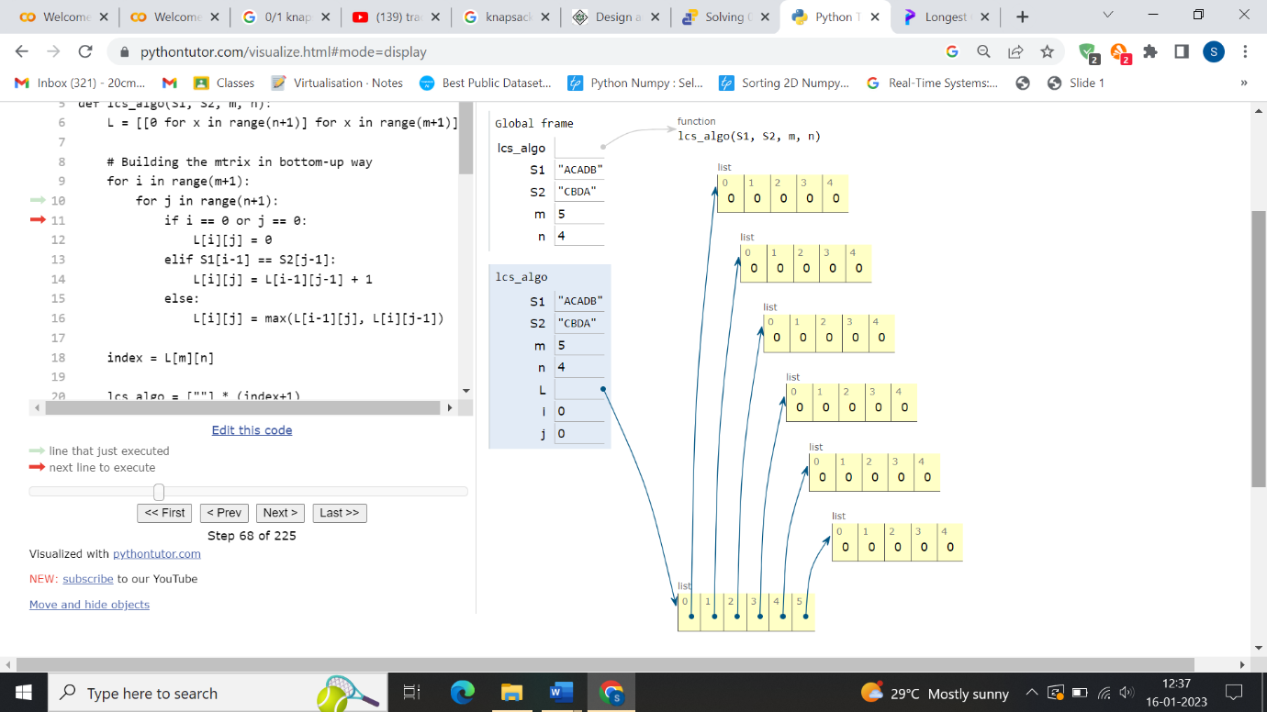**TRACING:**

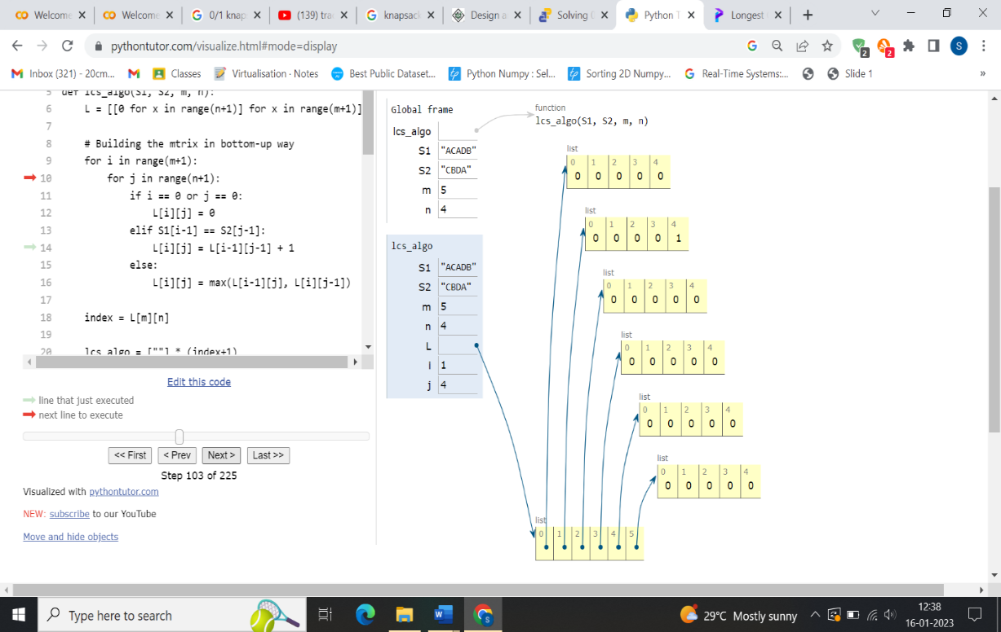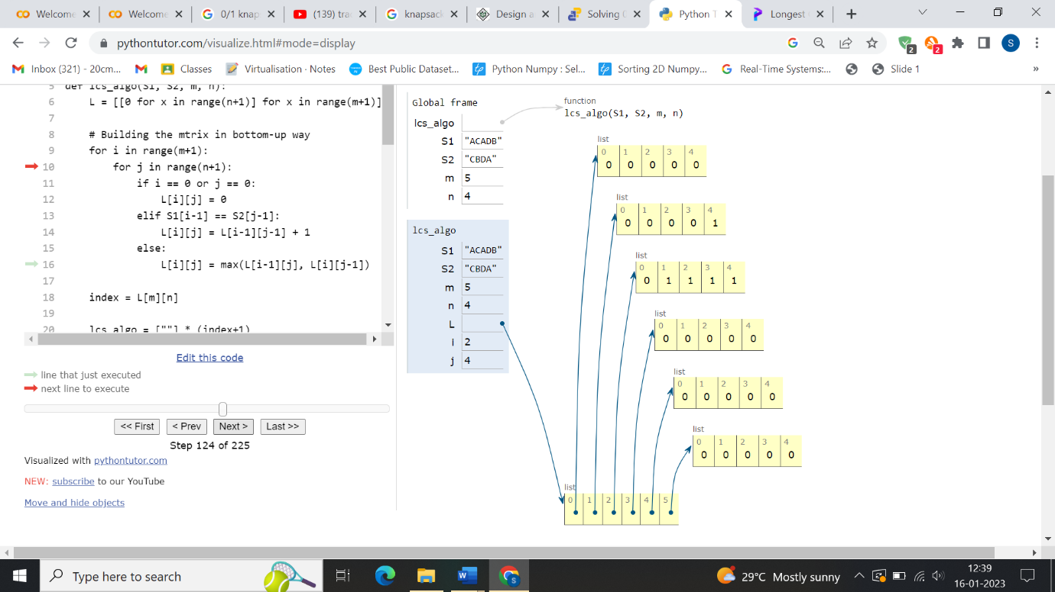

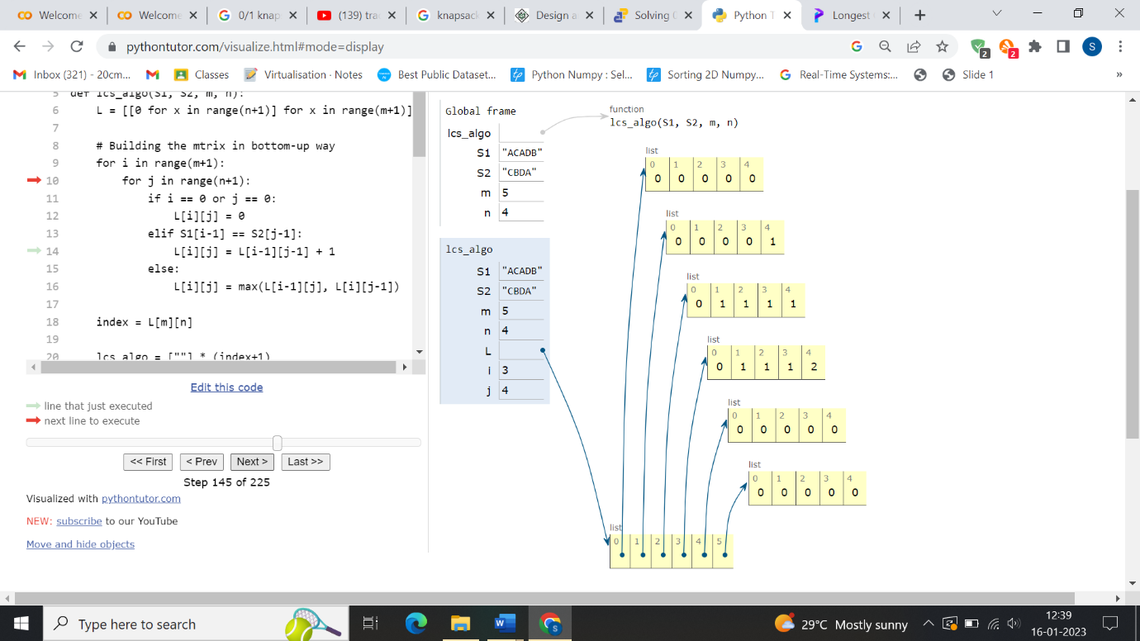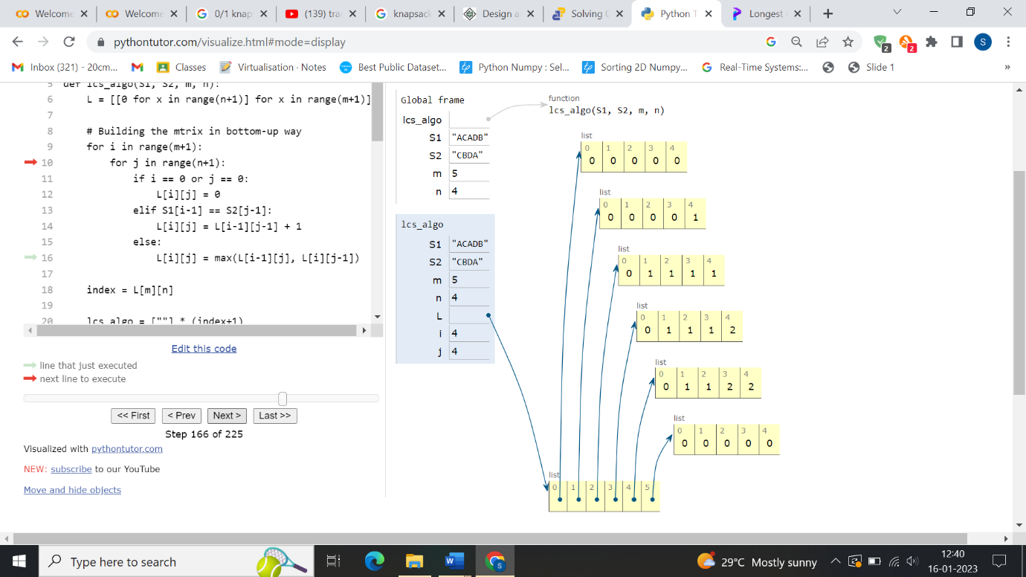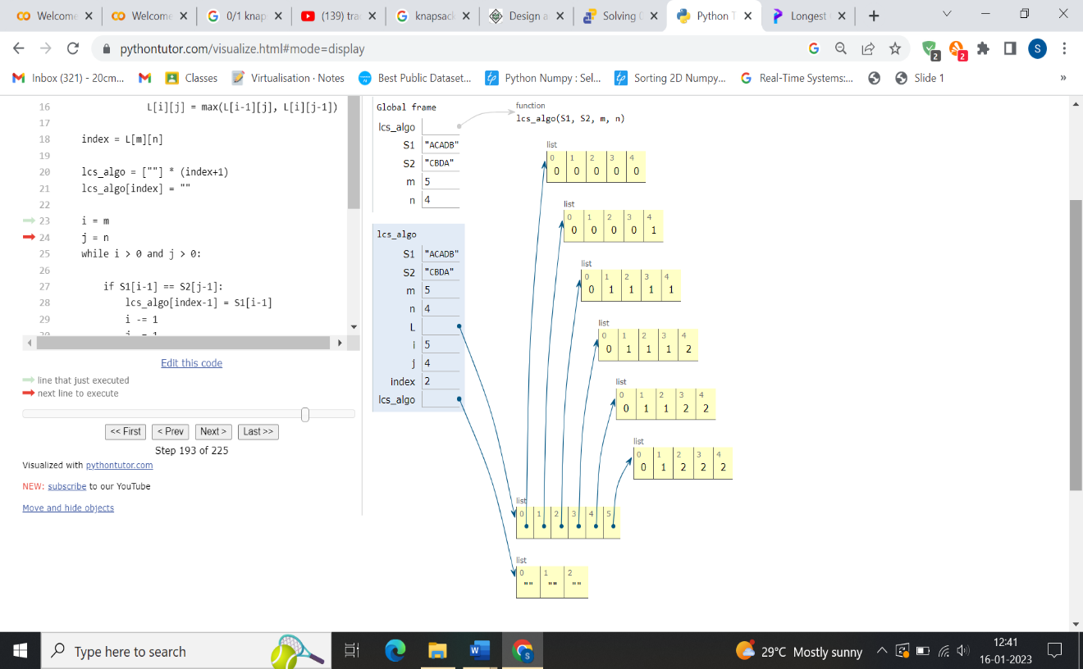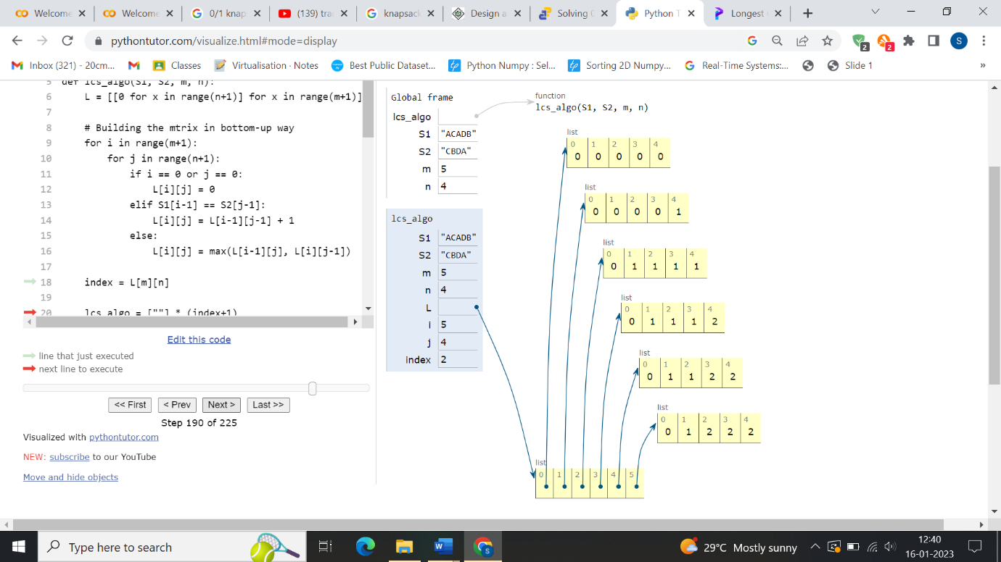

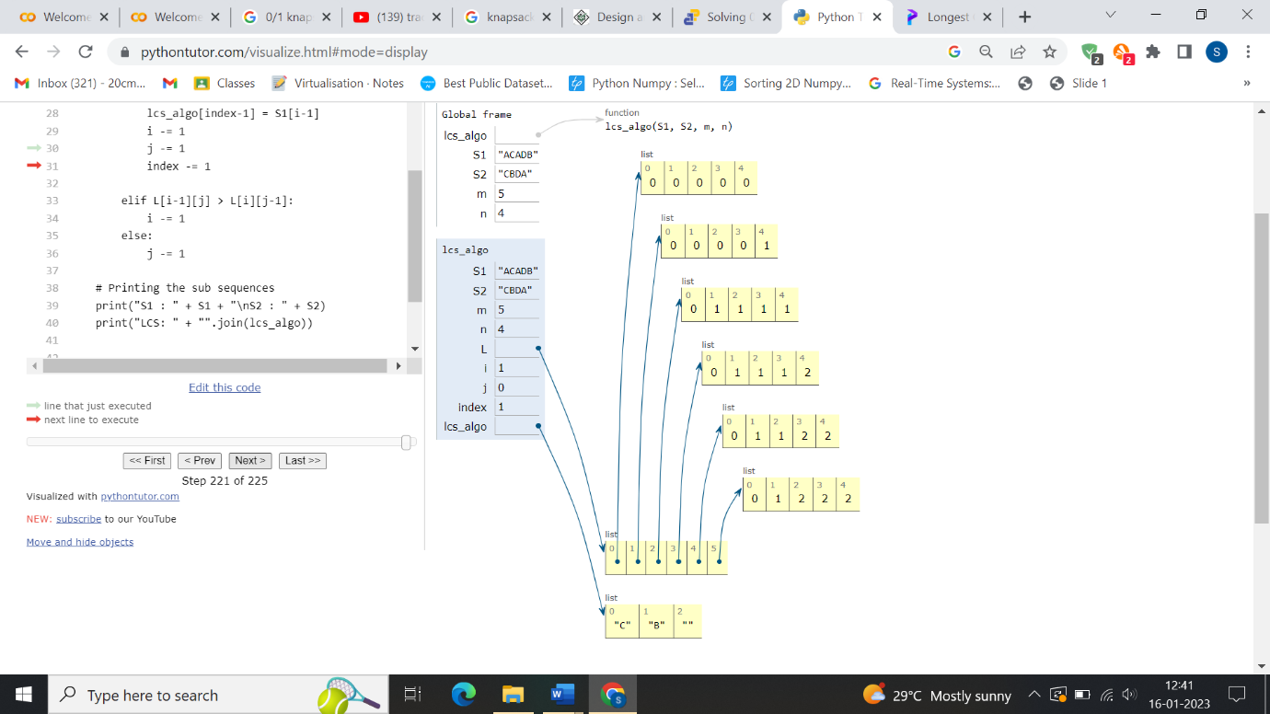

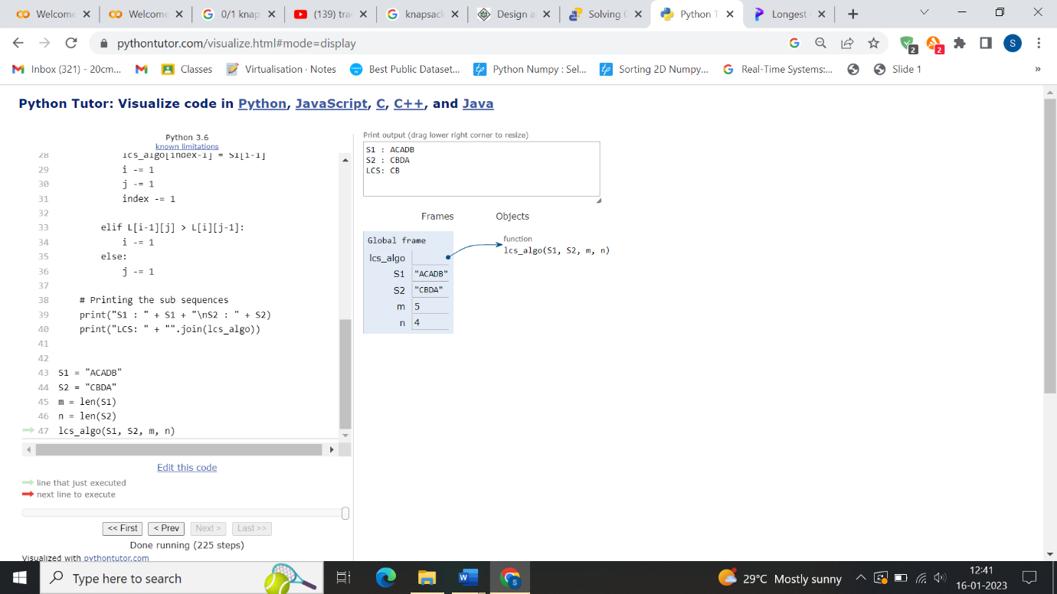

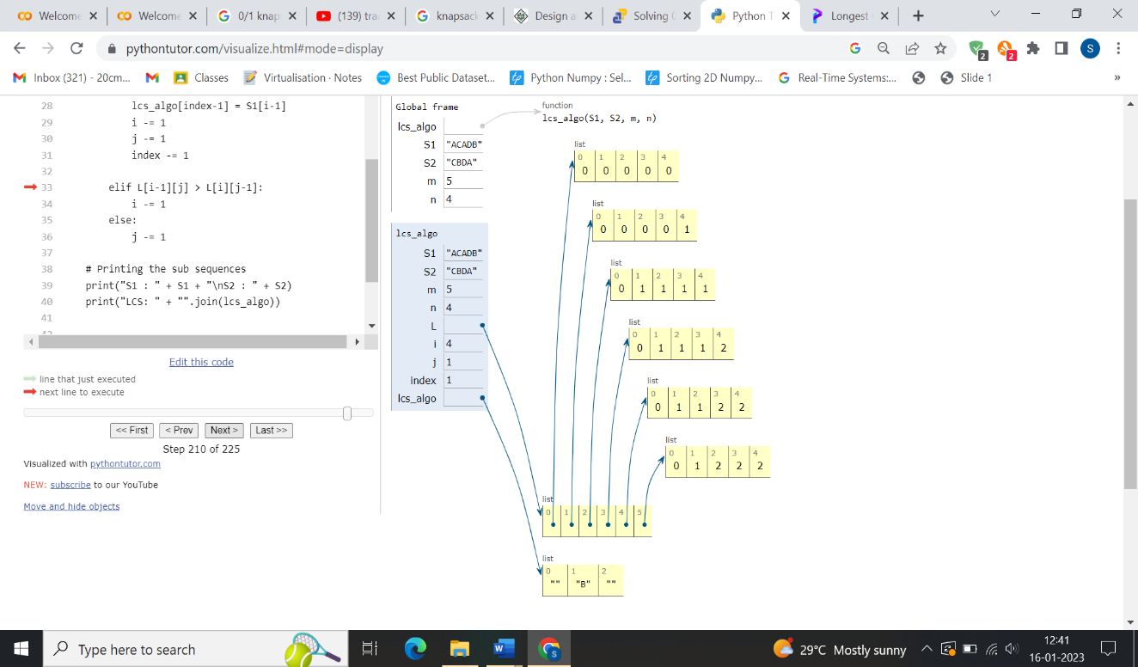

**0/1 KNAPSACK PROBLEM:**

**def** knapSack(W, wt, val):

    n**=**len(val)

    table **=** [[0 **for** x **in** range(W **+** 1)] **for** x **in** range(n **+** 1)]

**for** i **in** range(n **+** 1):

**for** j **in** range(W **+** 1):

**if** i **==** 0 **or** j **==** 0:

                table[i][j] **=** 0

**elif** wt[i**-**1] <**=** j:

                table[i][j] **=** max(val[i**-**1]

**+** table[i**-**1][j**-**wt[i**-**1]],  table[i**-**1][j])

**else**:

                table[i][j] **=** table[i**-**1][j]

**return** table[n][W]

val **=** [5,1,2,3]

wt **=** [3,4,5,1]

W **=** 10

 print(knapSack(W, wt, val))

**OUTPUT:**

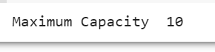

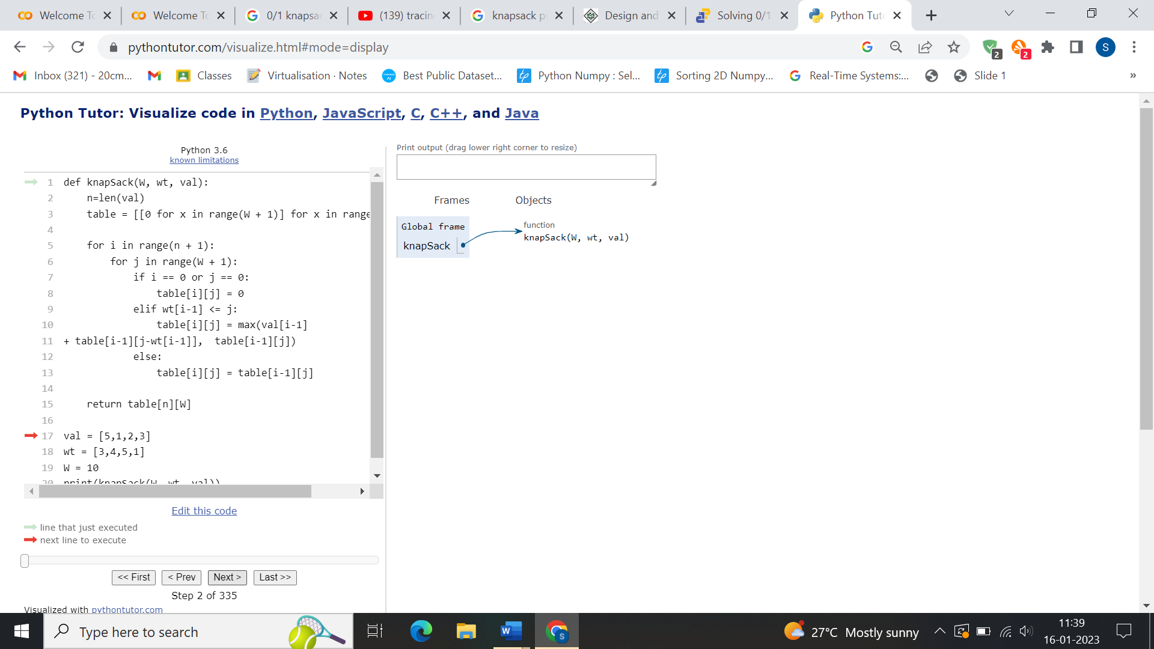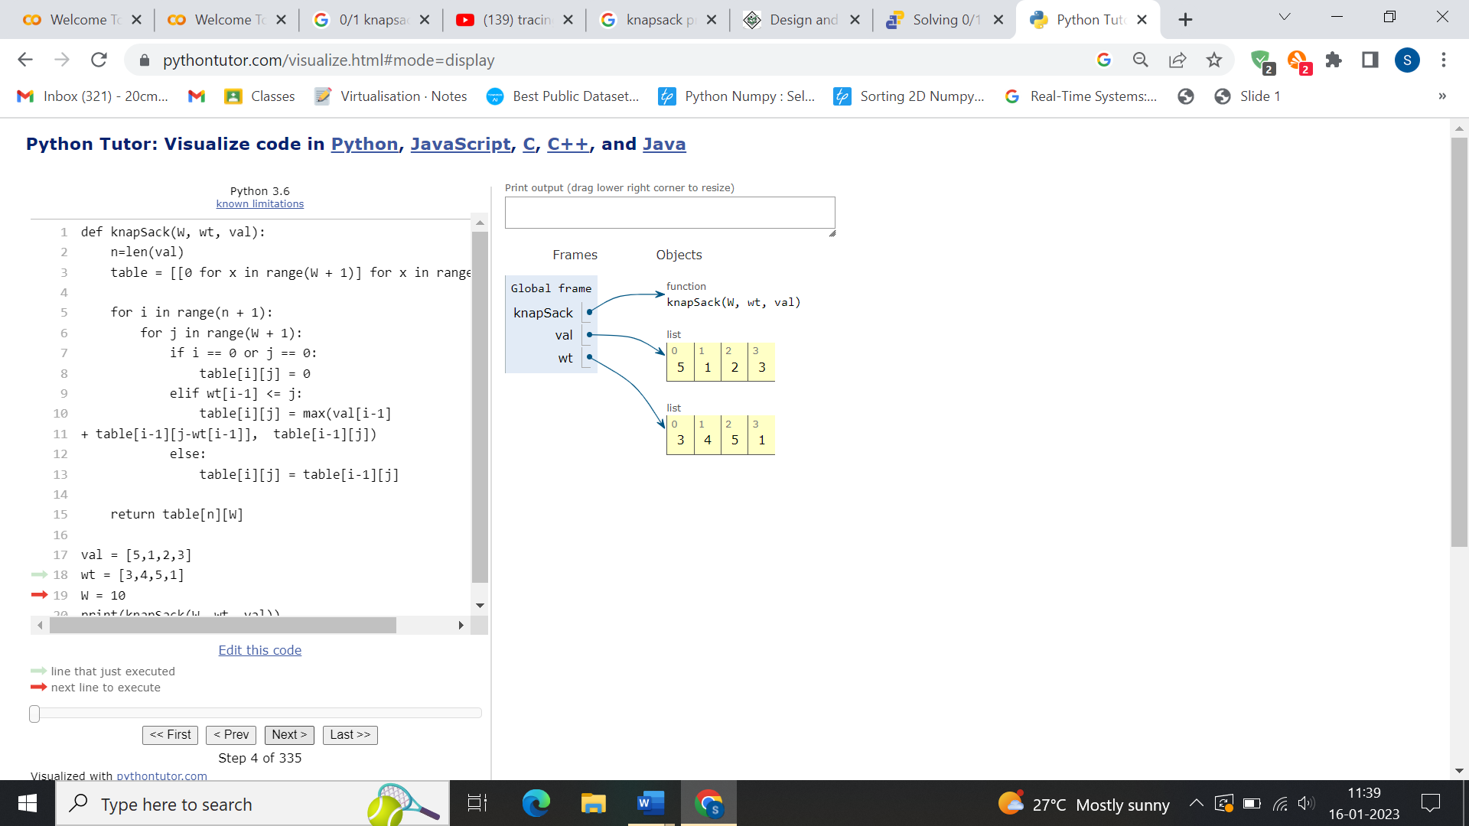**TRACING:**

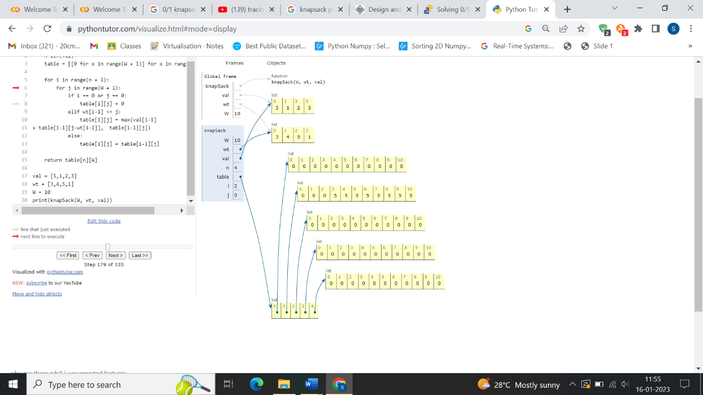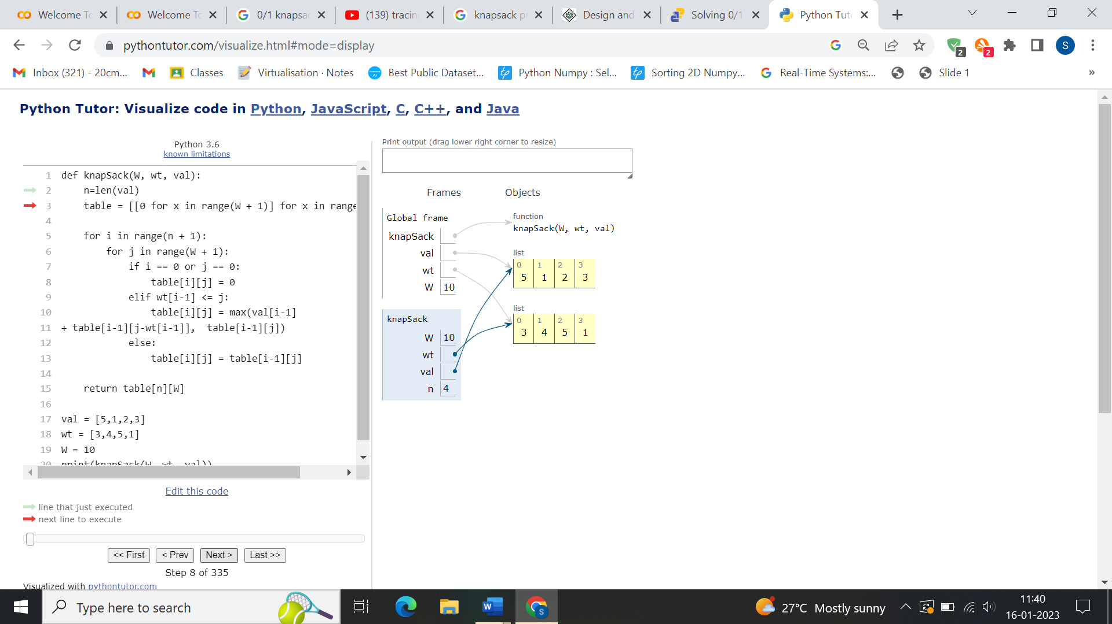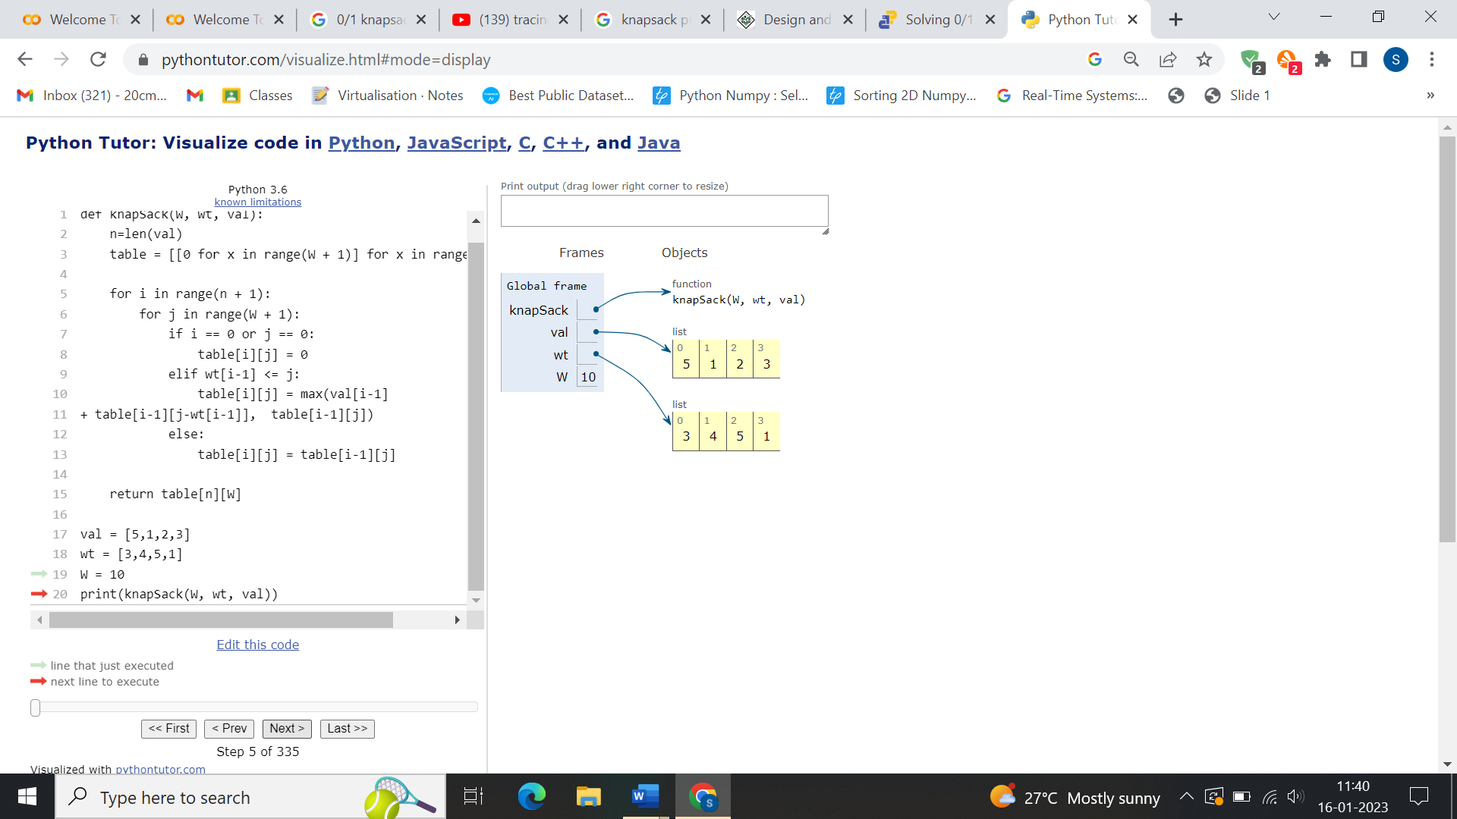

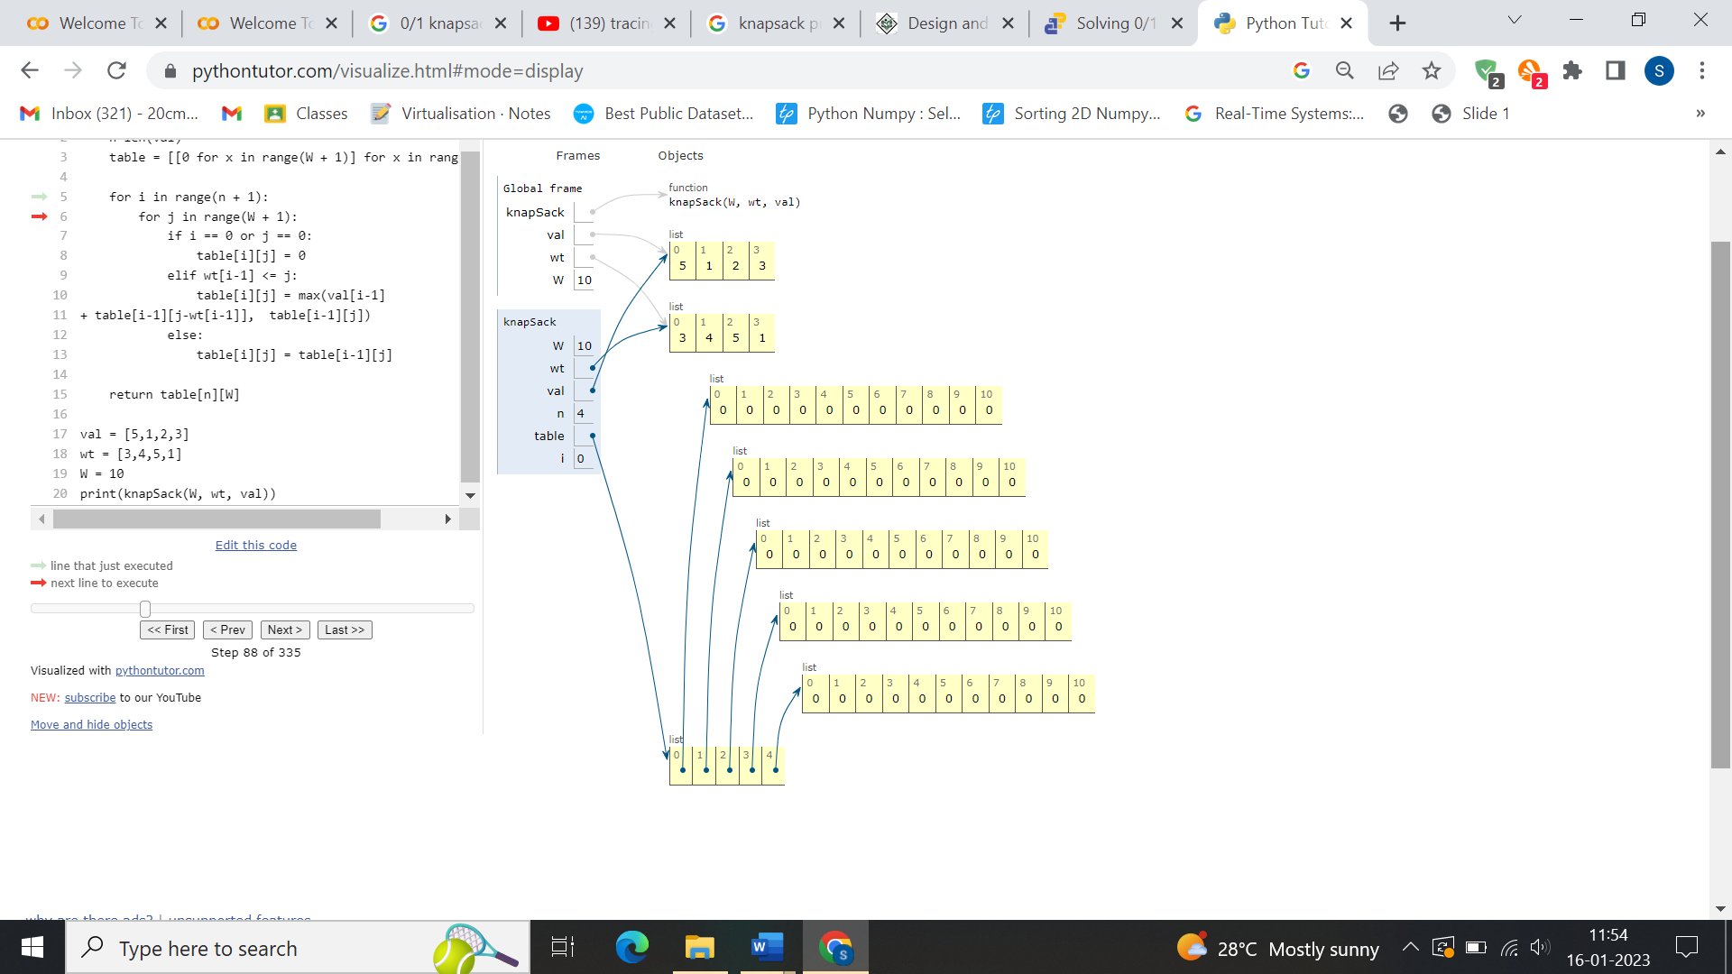

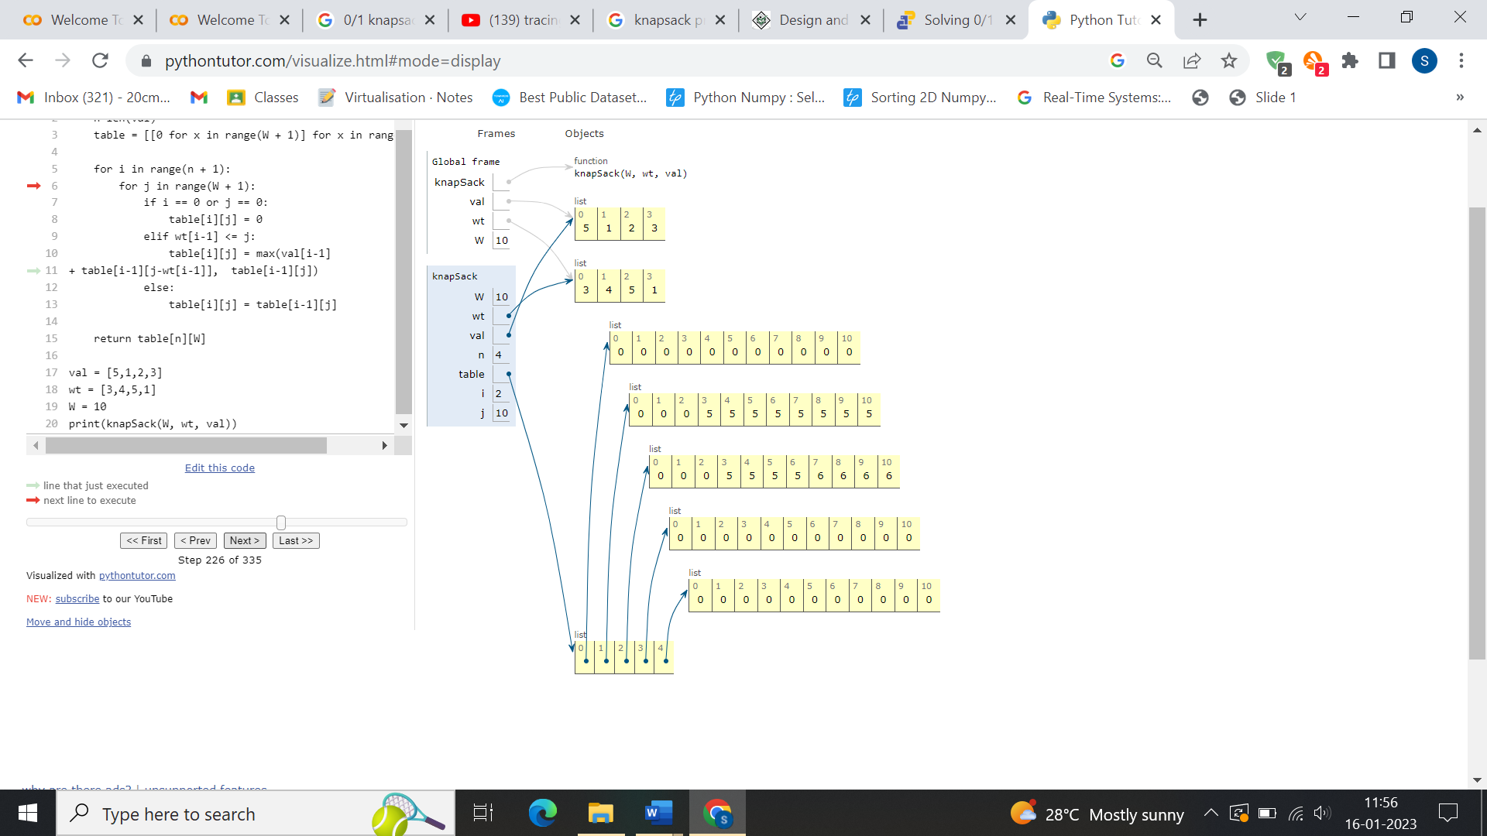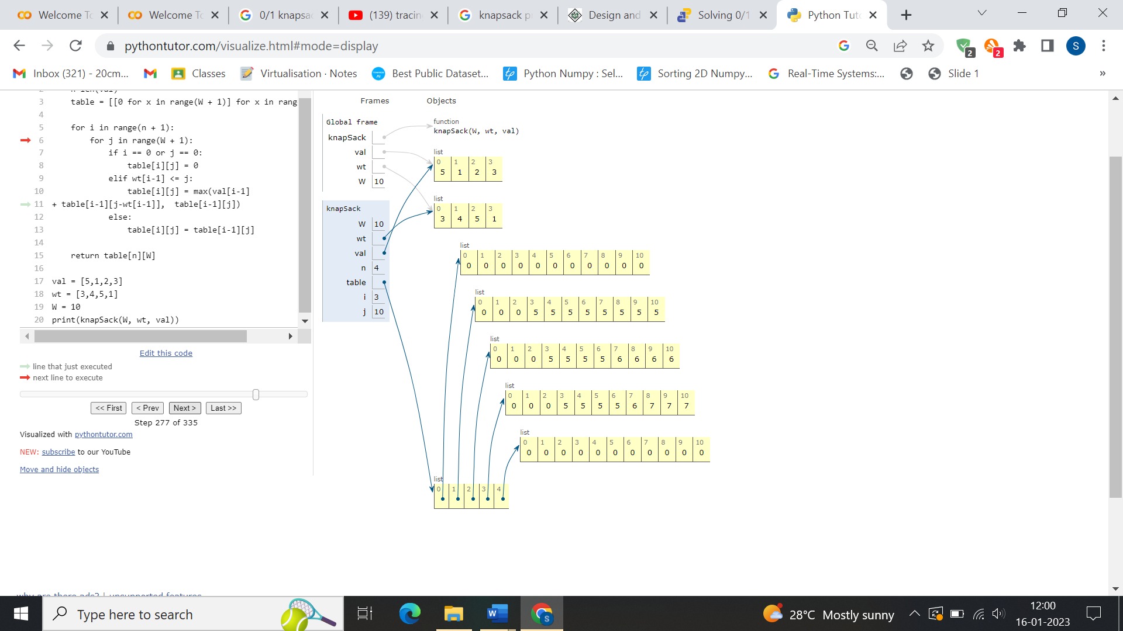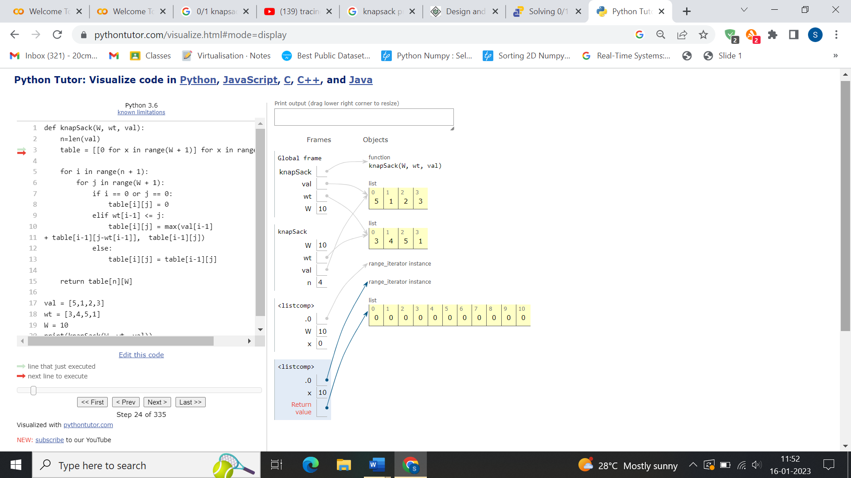

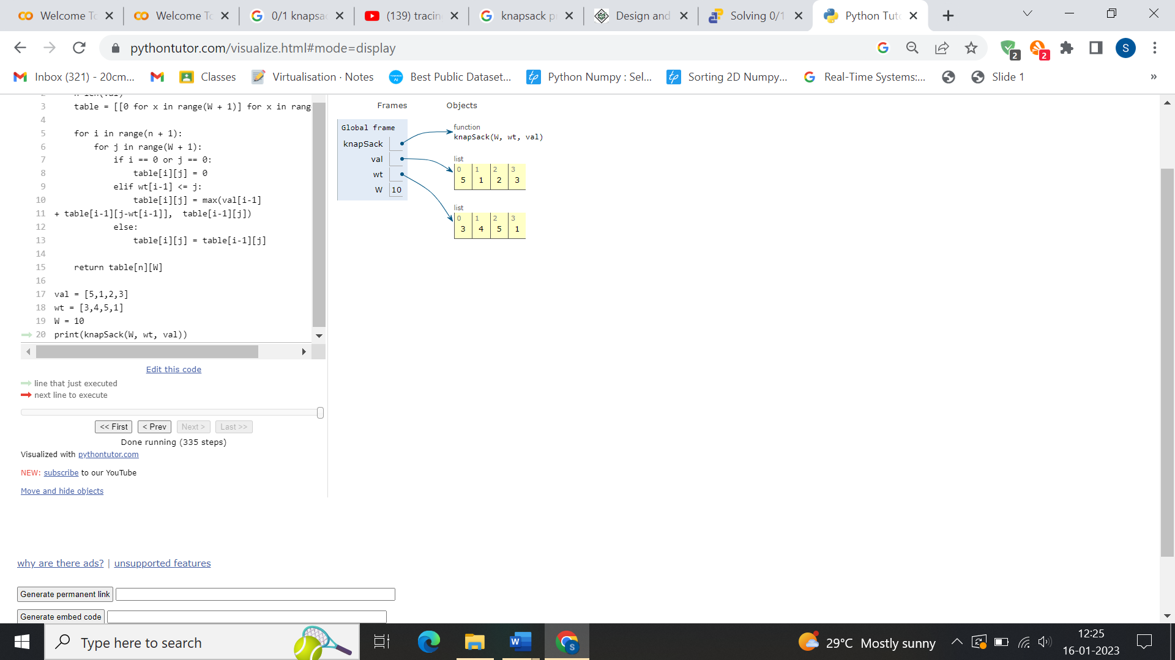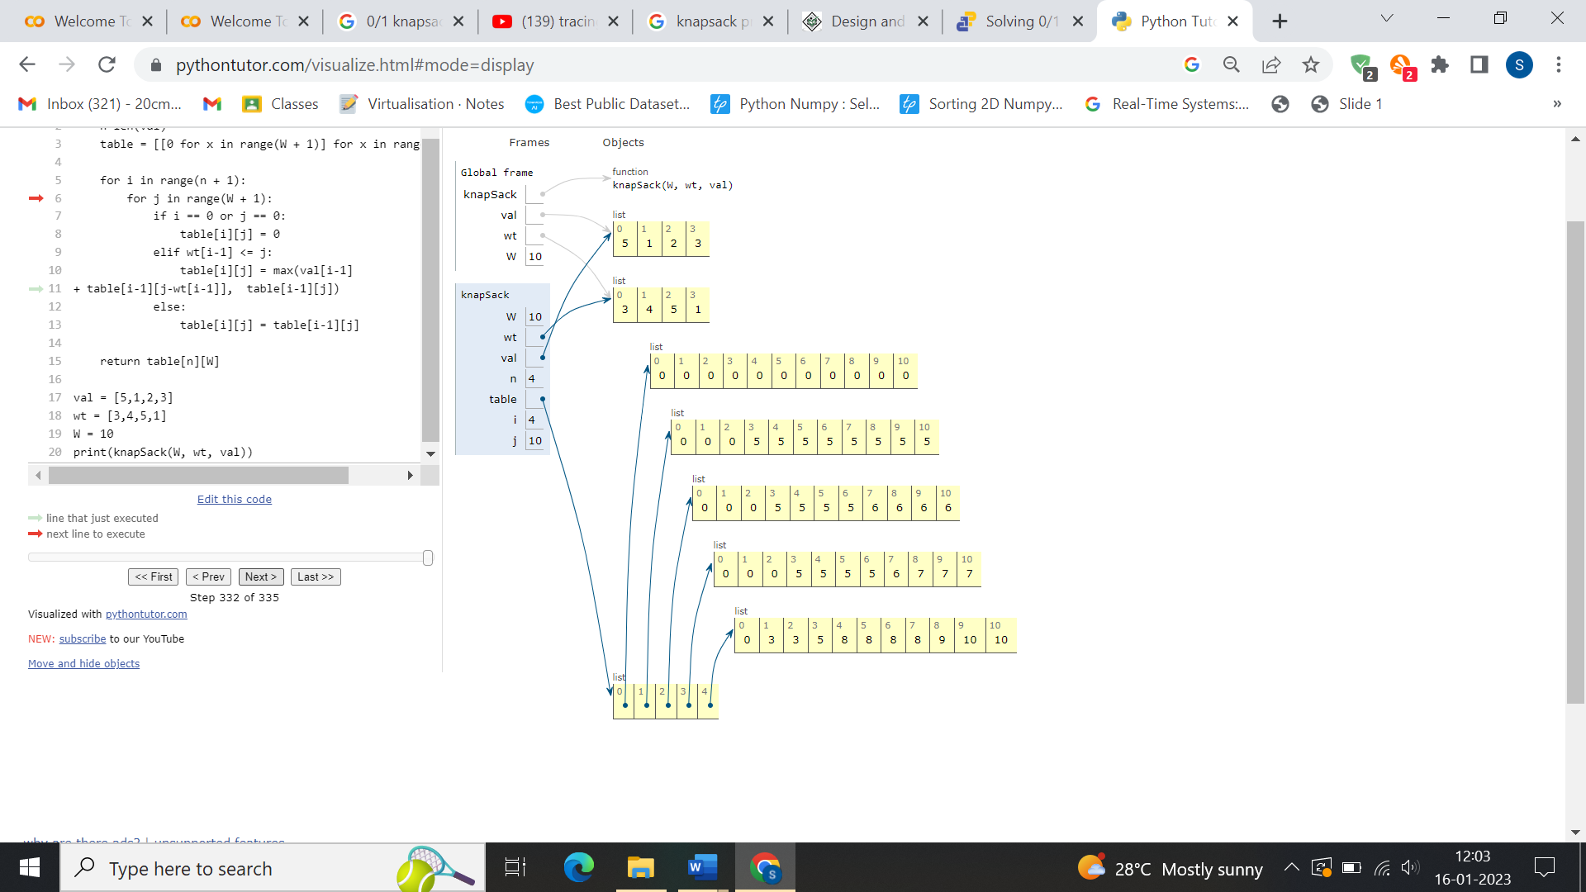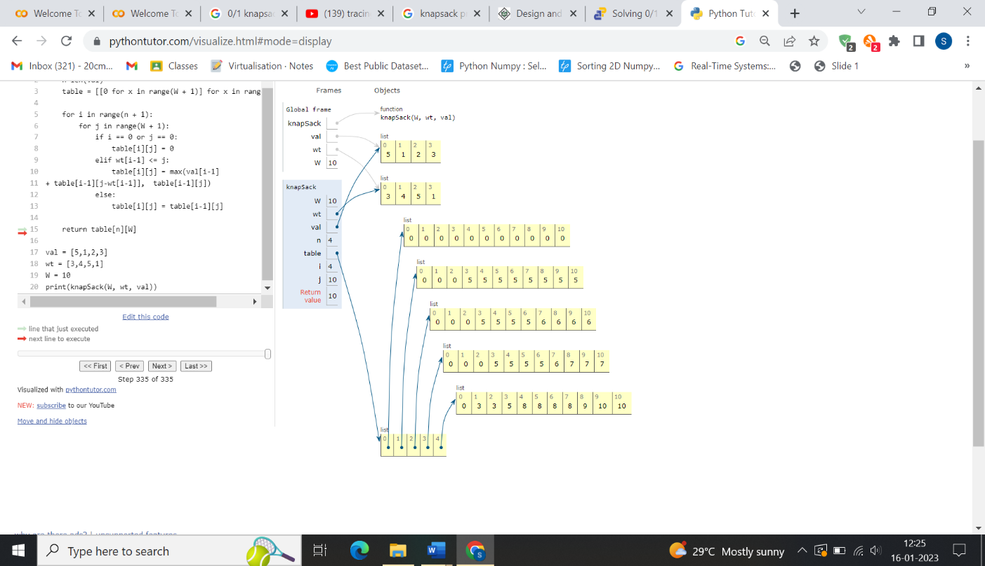

**PROGRAM:**

**DJIKSTRA’S ALGORITHM**

class Graph():

def __init__(self, vertices):

self.V = vertices

self.graph = [[0 for column in range(vertices)]

for row in range(vertices)]

def printSolution(self, dist):

print("Vertex \t Distance from Source")

for node in range(self.V):

print(node, "\t\t", dist[node])

# A utility function to find the vertex with

# minimum distance value, from the set of vertices

# not yet included in shortest path tree

def minDistance(self, dist, sptSet):

# Initialize minimum distance for next node

min = 1e7

# Search not nearest vertex not in the

# shortest path tree

for v in range(self.V):

if dist[v] < min and sptSet[v] == False:

min = dist[v]

min_index = v

return min_index

# Function that implements Dijkstra's single source

# shortest path algorithm for a graph represented

# using adjacency matrix representation

def dijkstra(self, src):

dist = [1e7] * self.V

dist[src] = 0

sptSet = [False] * self.V

for cout in range(self.V):

# Pick the minimum distance vertex from

# the set of vertices not yet processed.

# u is always equal to src in first iteration

u = self.minDistance(dist, sptSet)

# Put the minimum distance vertex in the

# shortest path tree

sptSet[u] = True

# Update dist value of the adjacent vertices

# of the picked vertex only if the current

# distance is greater than new distance and

# the vertex in not in the shortest path tree

for v in range(self.V):

if (self.graph[u][v] > 0 and

sptSet[v] == False and

dist[v] > dist[u] + self.graph[u][v]):

dist[v] = dist[u] + self.graph[u][v]

self.printSolution(dist)

g = Graph(9)

g.graph = [[0, 4, 0, 0, 0, 0, 0, 8, 0],

[4, 0, 8, 0, 0, 0, 0, 11, 0],

[0, 8, 0, 7, 0, 4, 0, 0, 2],

[0, 0, 7, 0, 9, 14, 0, 0, 0],

[0, 0, 0, 9, 0, 10, 0, 0, 0],

[0, 0, 4, 14, 10, 0, 2, 0, 0],

[0, 0, 0, 0, 0, 2, 0, 1, 6],

[8, 11, 0, 0, 0, 0, 1, 0, 7],

[0, 0, 2, 0, 0, 0, 6, 7, 0]

]

g.dijkstra(0)

**OUTPUT:**

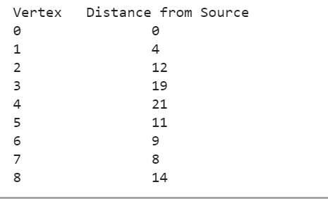

**TRACING:**

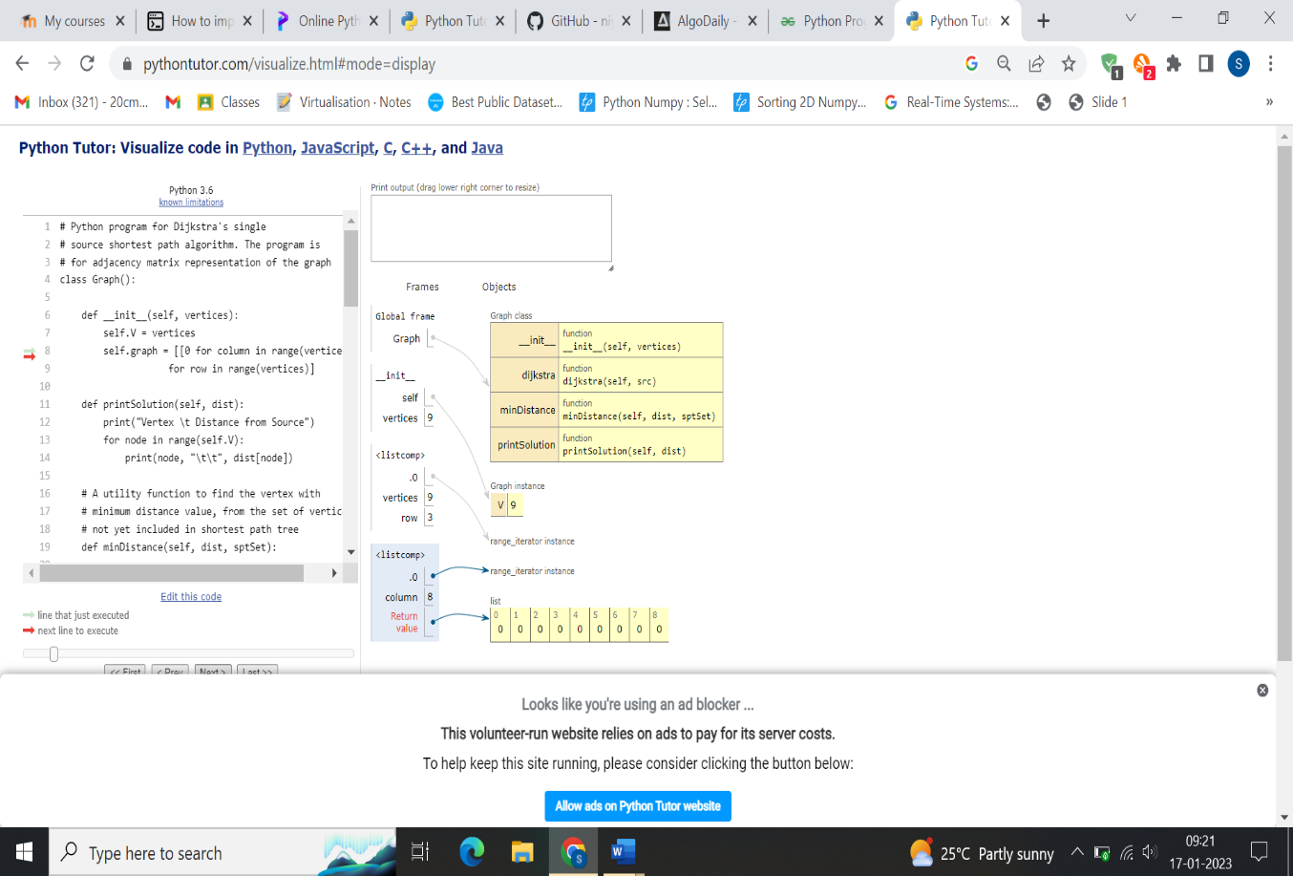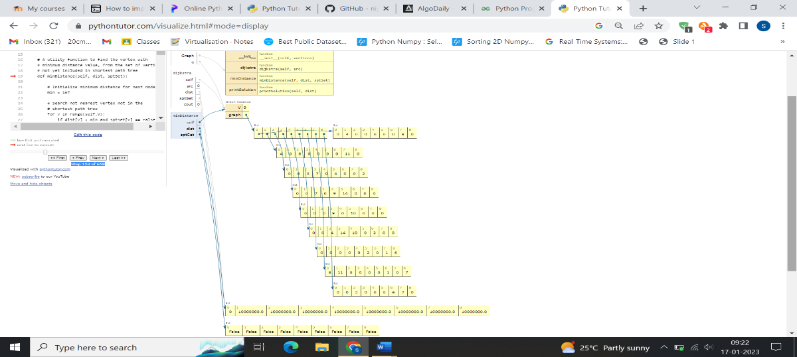

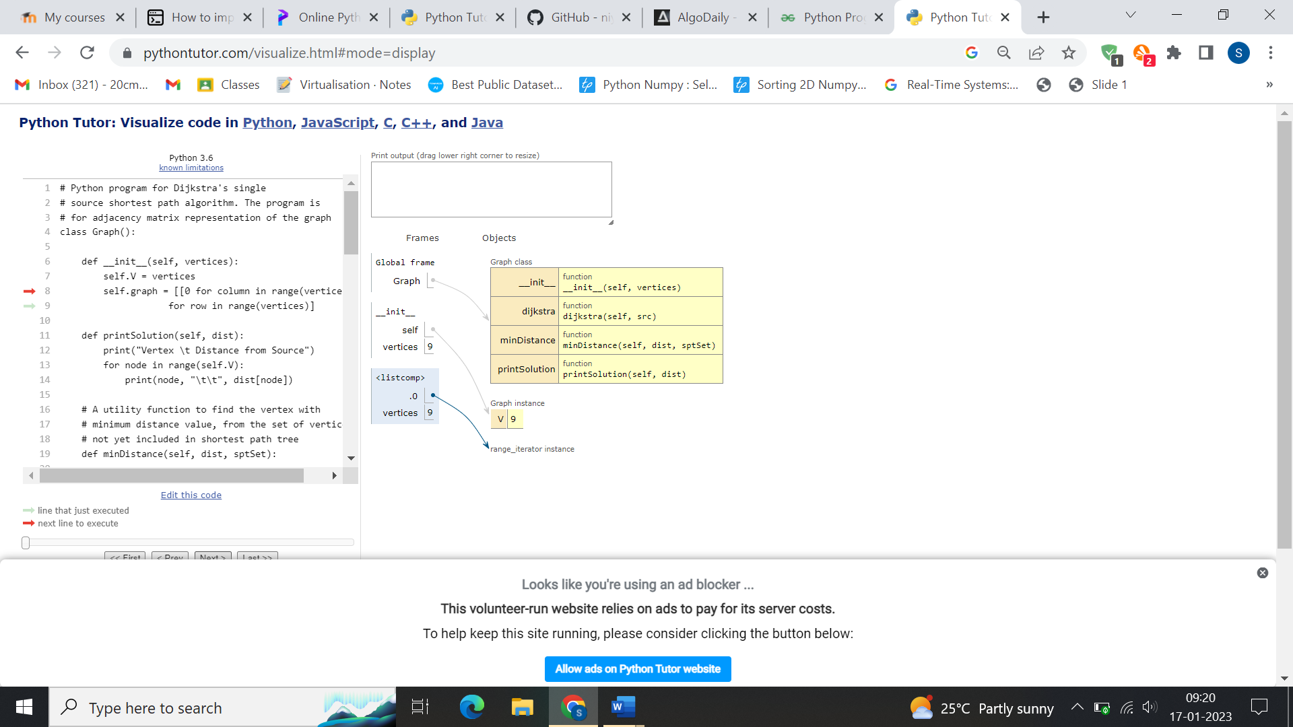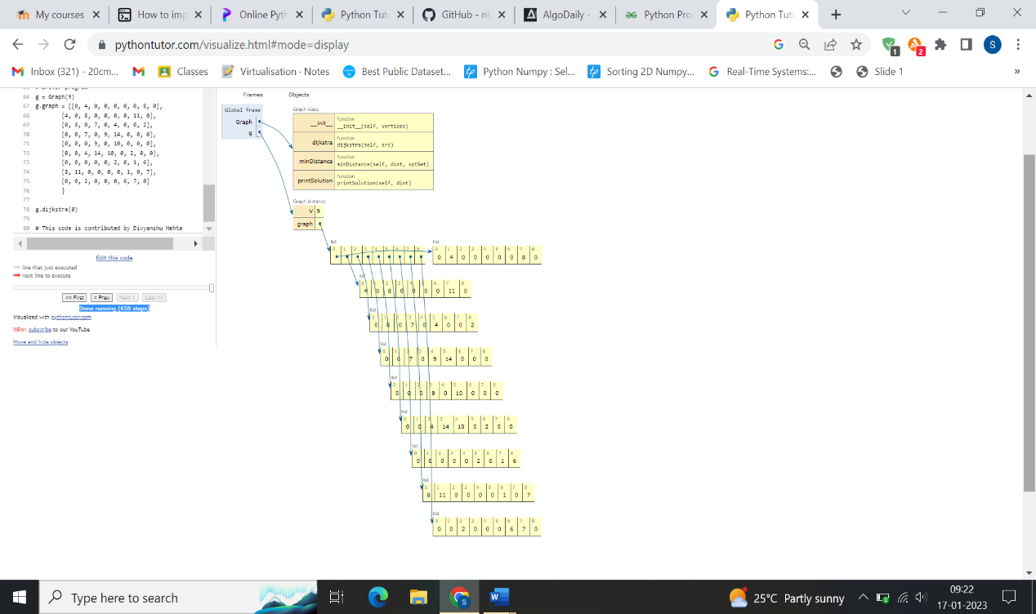

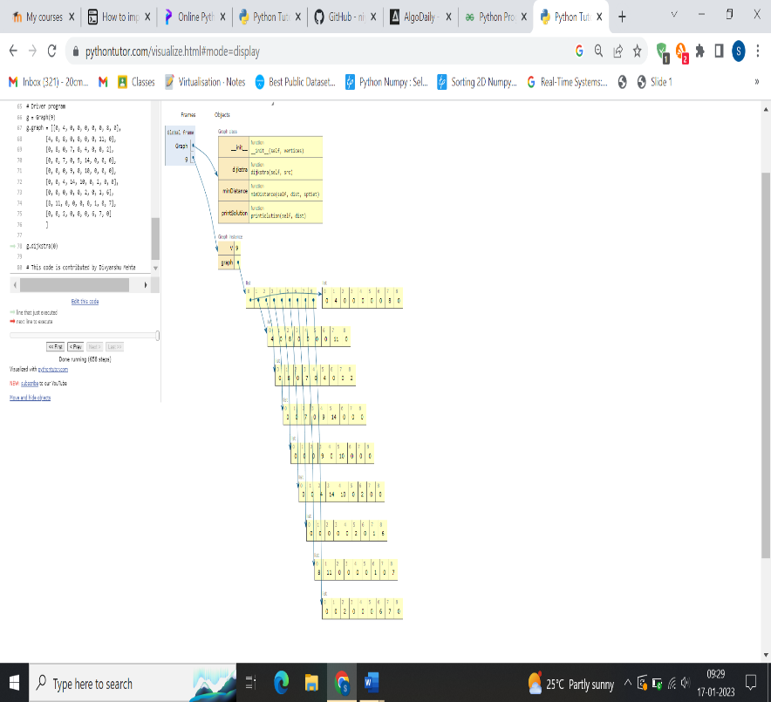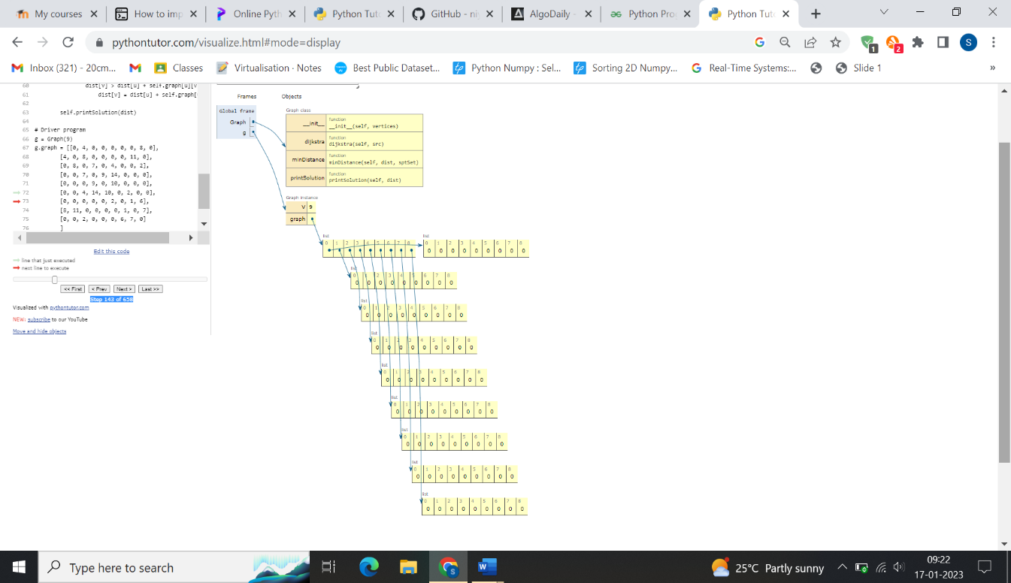

**BELLMAN FORD :**

# Bellman Ford Algorithm in Python

class Graph:

def __init__(self, vertices):

self.V = vertices # Total number of vertices in the graph

self.graph = [] # Array of edges

# Add edges

def add_edge(self, s, d, w):

self.graph.append([s, d, w])

# Print the solution

def print_solution(self, dist):

print("Vertex Distance from Source")

for i in range(self.V):

print("{0}\t\t{1}".format(i, dist[i]))

def bellman_ford(self, src):

# Step 1: fill the distance array and predecessor array

dist = [float("Inf")] * self.V

# Mark the source vertex

dist[src] = 0

# Step 2: relax edges |V| - 1 times

for _ in range(self.V - 1):

for s, d, w in self.graph:

if dist[s] != float("Inf") and dist[s] + w < dist[d]:

dist[d] = dist[s] + w

# Step 3: detect negative cycle

# if value changes then we have a negative cycle in the graph

# and we cannot find the shortest distances

for s, d, w in self.graph:

if dist[s] != float("Inf") and dist[s] + w < dist[d]:

print("Graph contains negative weight cycle")

return

# No negative weight cycle found!

# Print the distance and predecessor array

self.print_solution(dist)

g = Graph(5)

g.add_edge(0, 1, 5)

g.add_edge(0, 2, 4)

g.add_edge(1, 3, 3)

g.add_edge(2, 1, 6)

g.add_edge(3, 2, 2)

g.bellman_ford(0)

**OUTPUT**

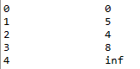

**TRACING**

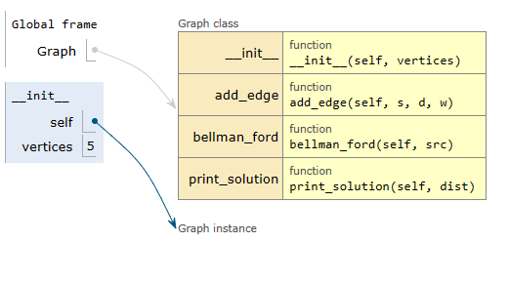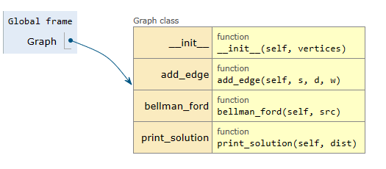

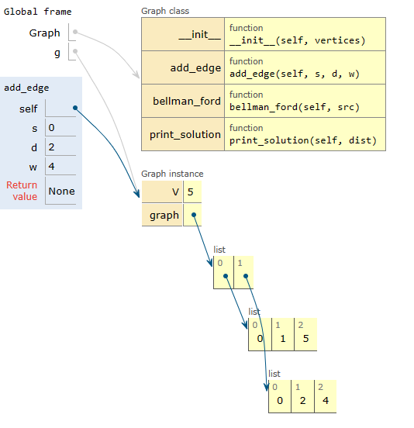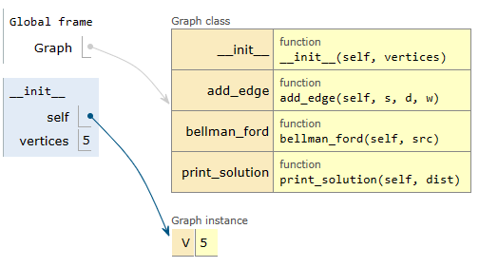

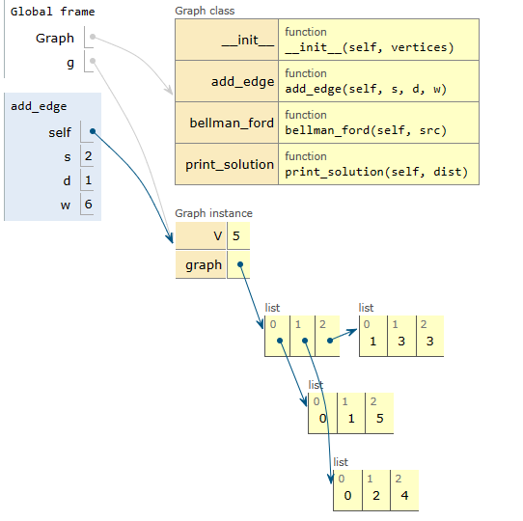

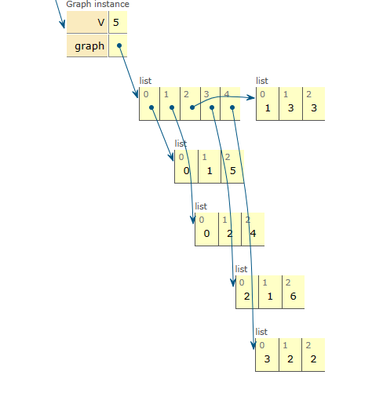

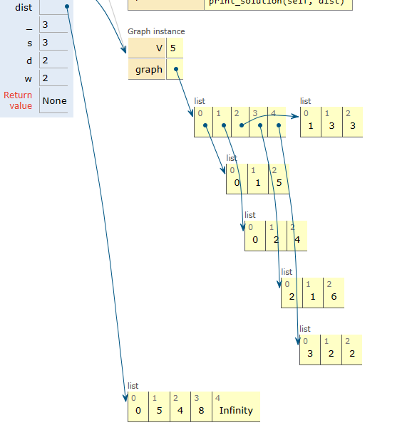

**PROGRAM:**

# The number of vertices

nV = 4

INF = 999

# Algorithm implementation

def floyd_warshall(G):

distance = list(map(lambda i: list(map(lambda j: j, i)), G))

# Adding vertices individually

for k in range(nV):

for i in range(nV):

for j in range(nV):

distance[i][j] = min(distance[i][j], distance[i][k] + distance[k][j])

print_solution(distance)

# Printing the solution

def print_solution(distance):

for i in range(nV):

for j in range(nV):

if(distance[i][j] == INF):

print("INF", end=" ")

else:

print(distance[i][j], end=" ")

print(" ")

G = [[0, 3, INF, 5],

[2, 0, INF, 4],

[INF, 1, 0, INF],

[INF, INF, 2, 0]]

floyd_warshall(G)

**OUTPUT:**

0 3 7 5

2 0 6 4

3 1 0 5

5 3 2 0

**TRACING**

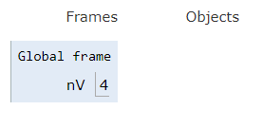

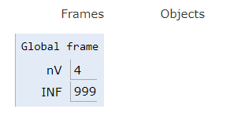

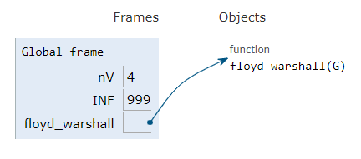

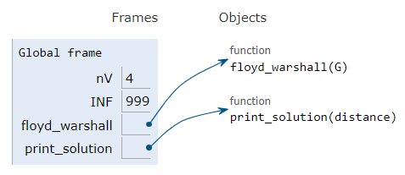

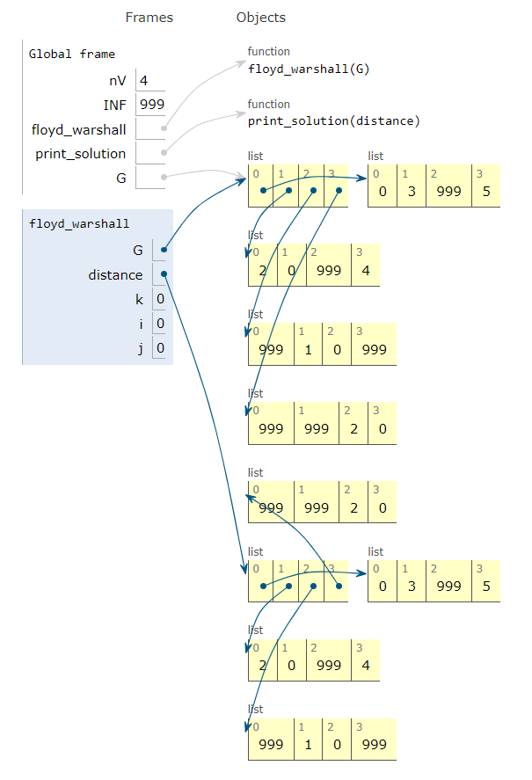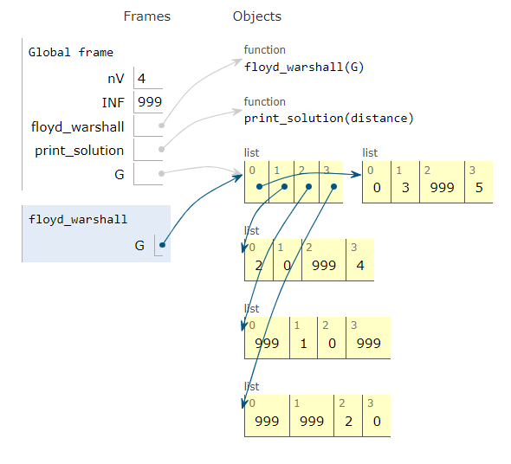

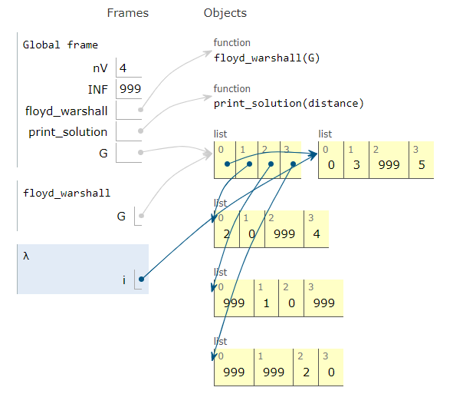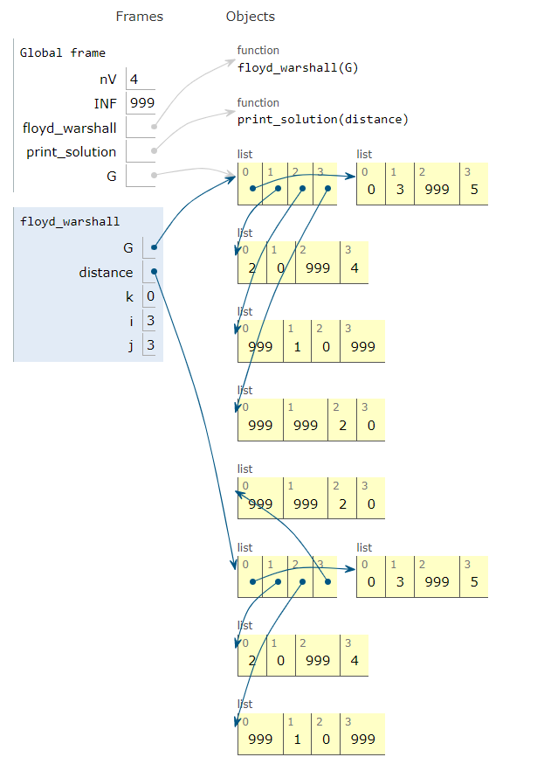

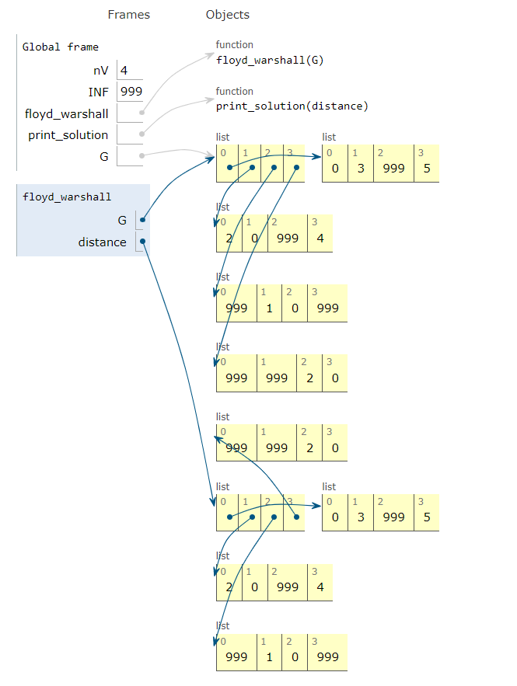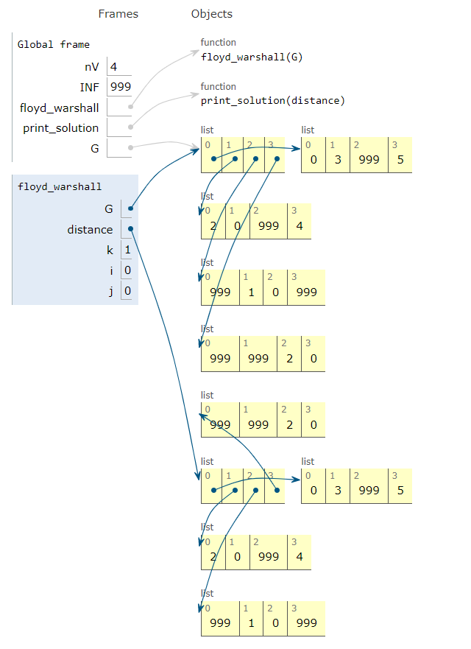

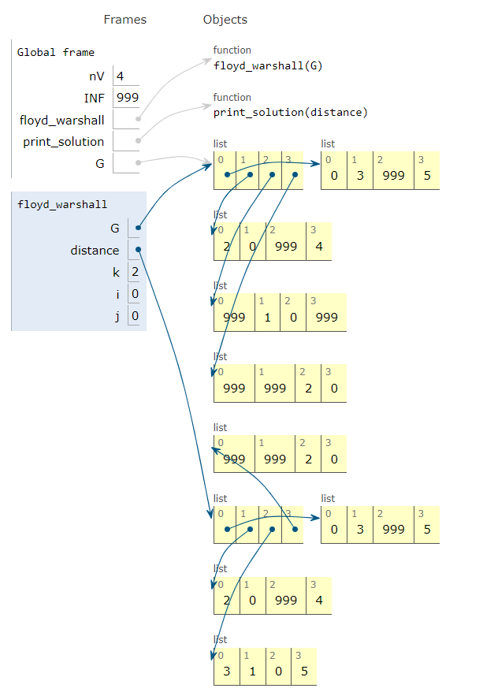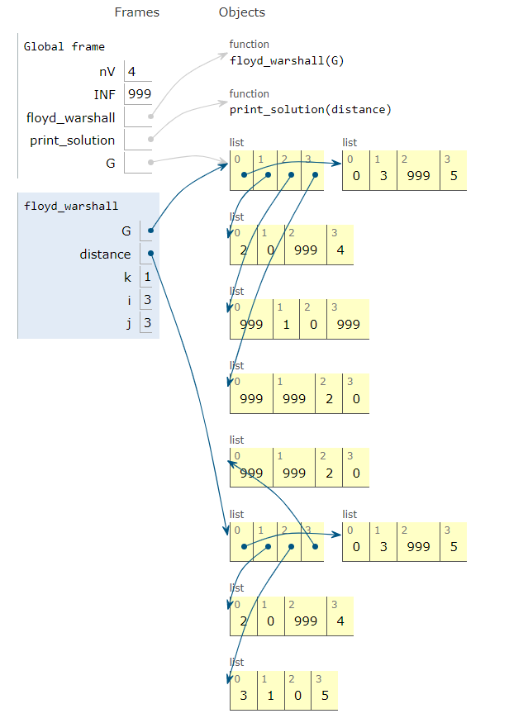

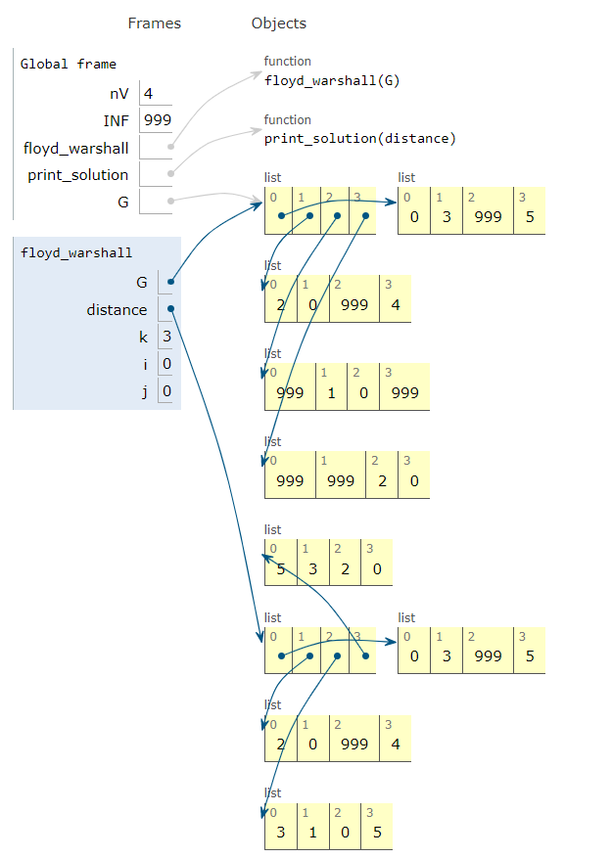

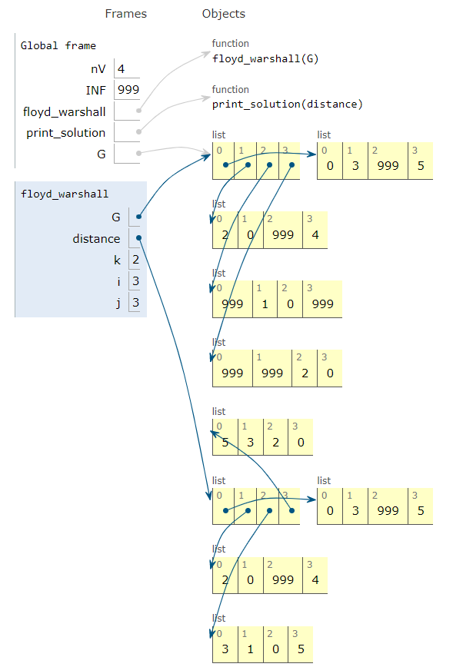

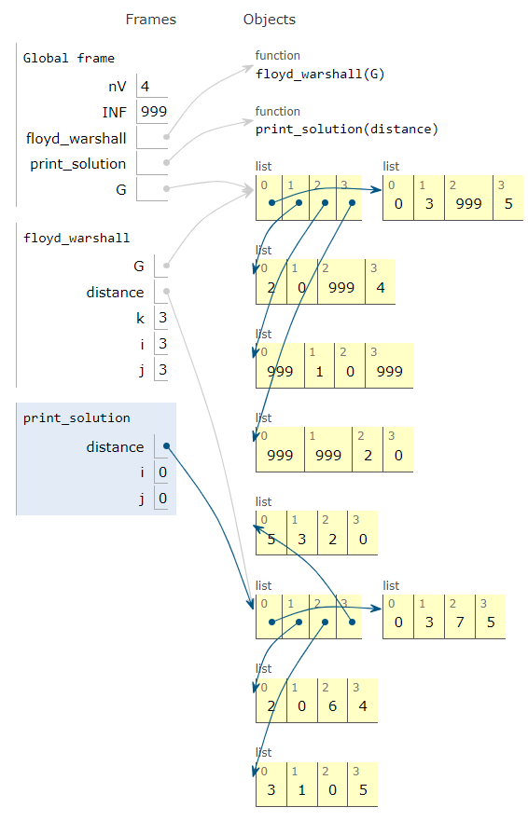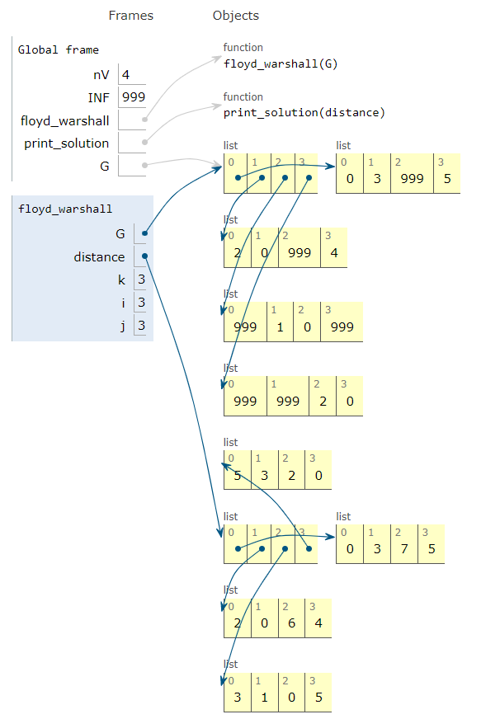**PROGRAM:**

**BFS:**

graph = {

'5' : ['3','7'],

'3' : ['2', '4'],

'7' : ['8'],

'2' : [],

'4' : ['8'],

'8' : []

}

visited = []

queue = []

**def** bfs(visited, graph, node):

visited.append(node)

queue.append(node)

**while** queue:

m = queue.pop(0)

**print** (m, end = " ")

**for** neighbour **in** graph[m]:

**if** neighbour **not** **in** visited:

visited.append(neighbour)

queue.append(neighbour)

**print**("Following is the Breadth-First Search")

bfs(visited, graph, '5')

**OUTPUT:**

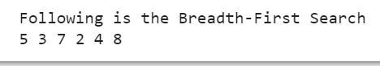

**TRACING:**

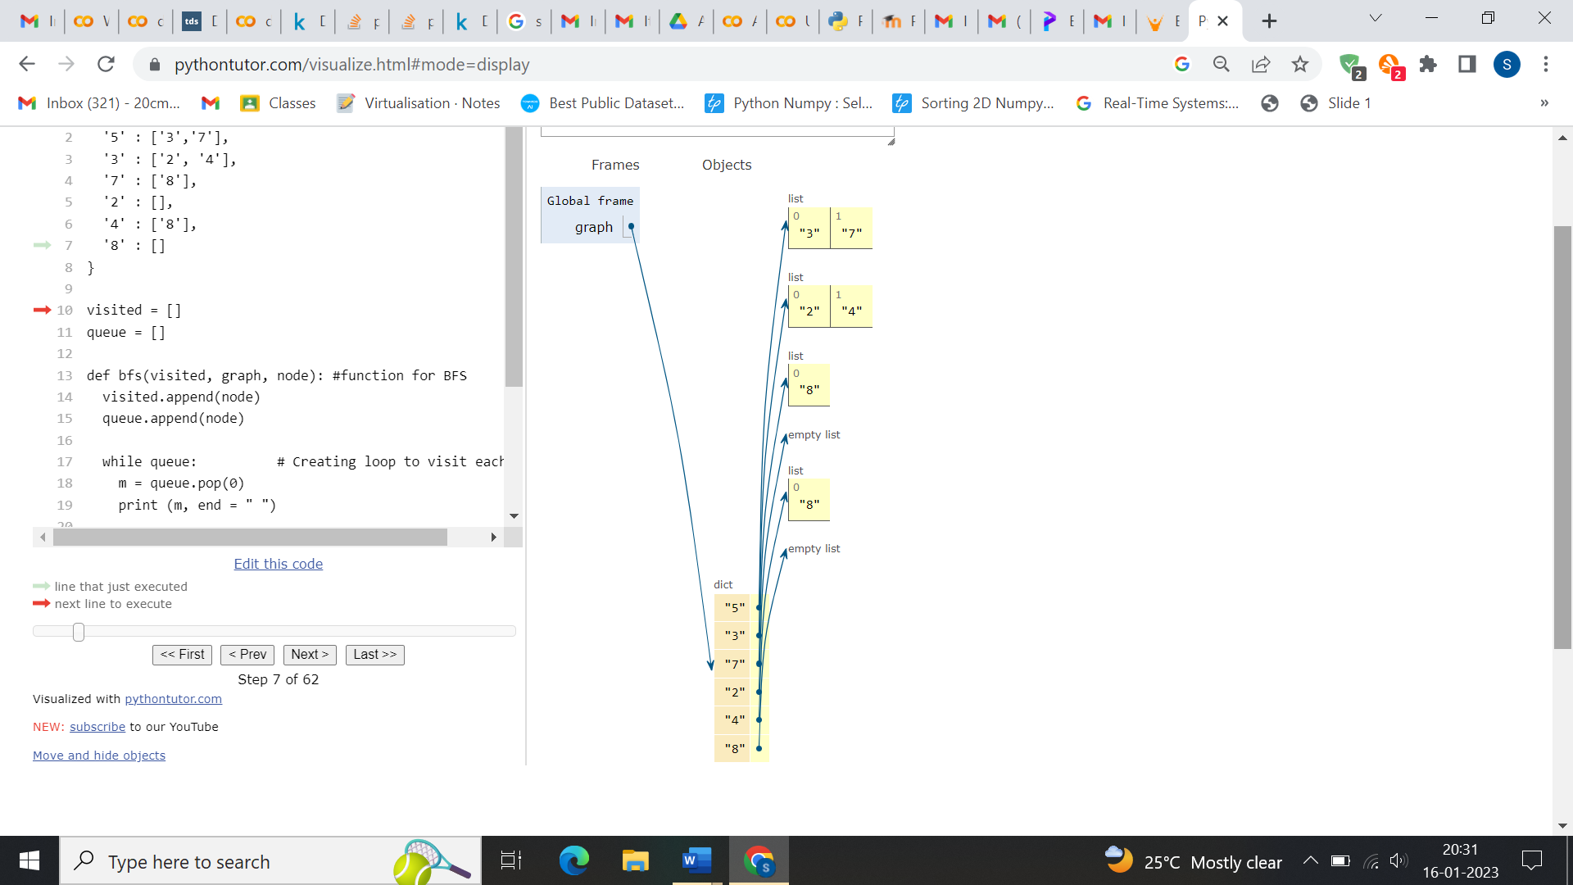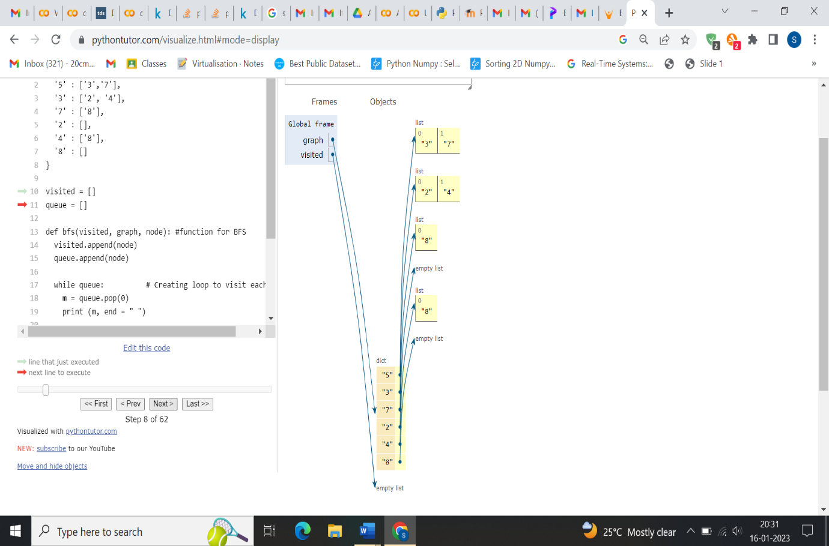

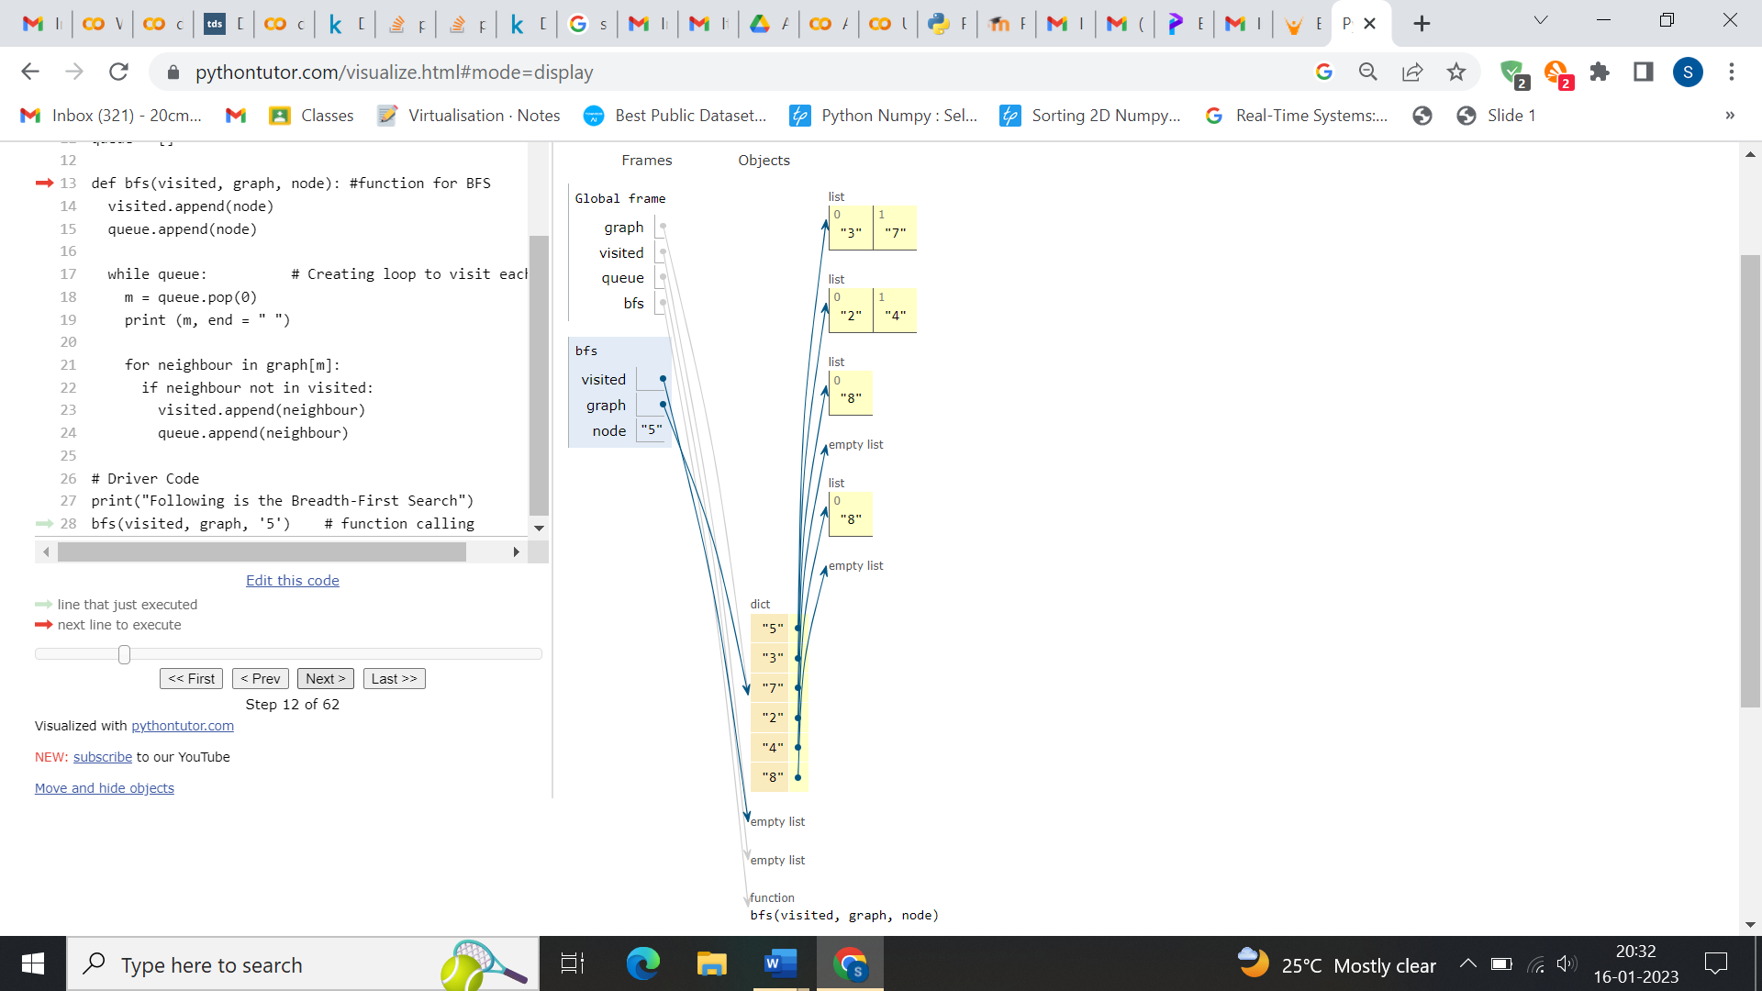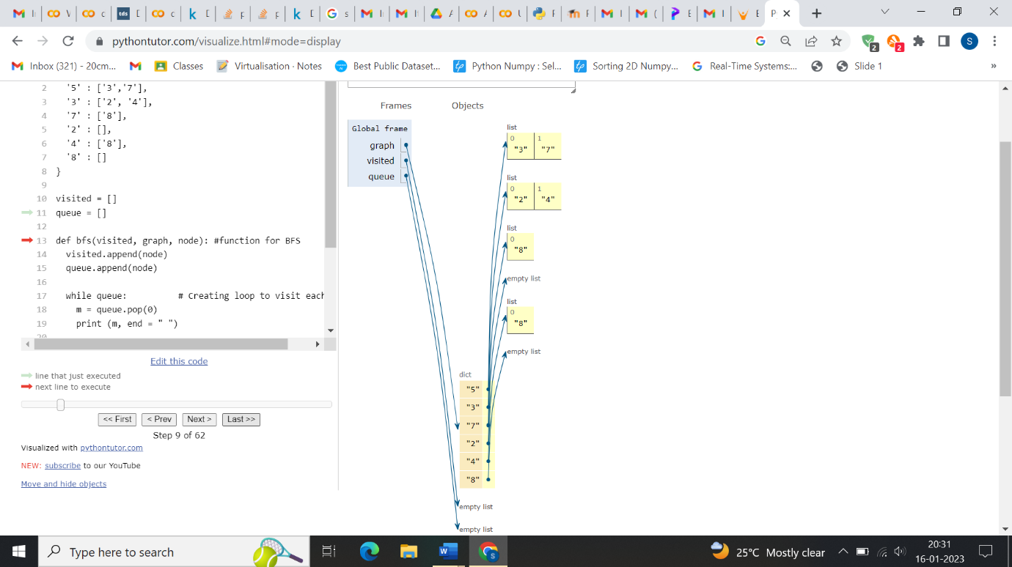

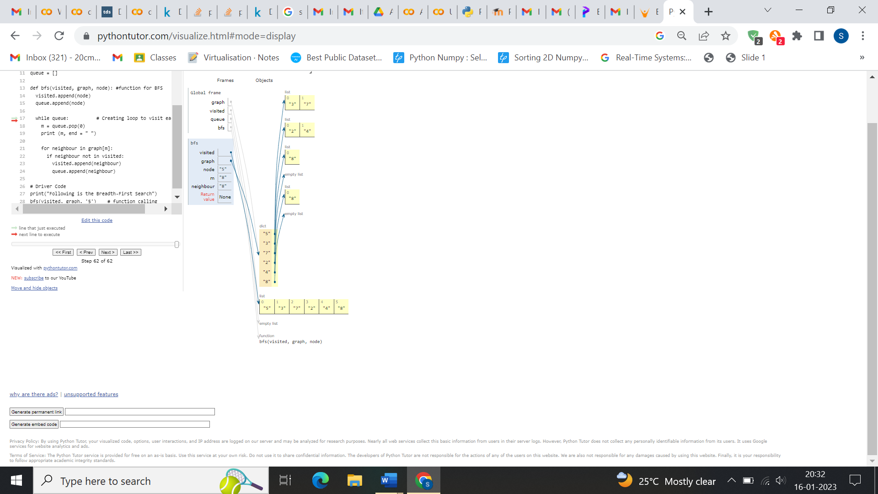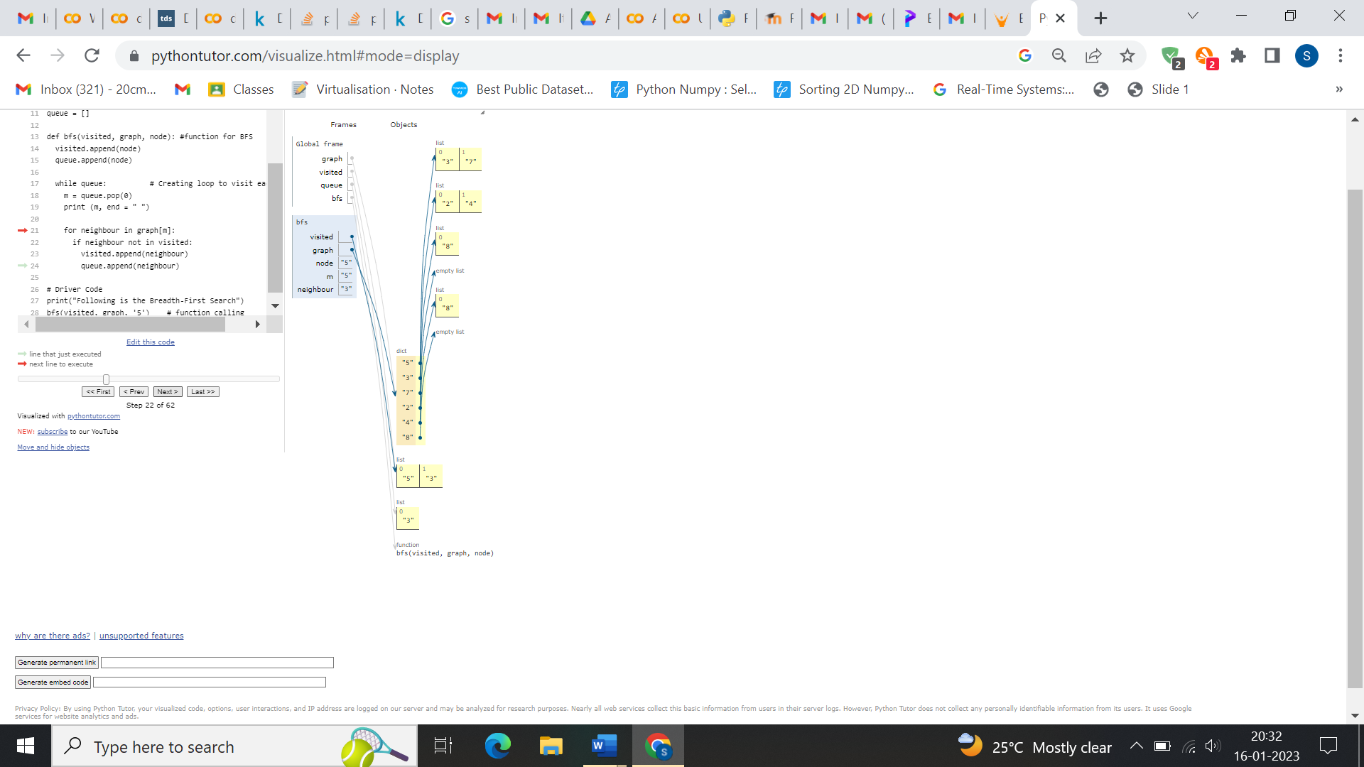

**DFS:**

graph = {

'5' : ['3','7'],

'3' : ['2', '4'],

'7' : ['8'],

'2' : [],

'4' : ['8'],

'8' : []

}

visited = set()

def dfs(visited, graph, node):

if node not in visited:

print (node)

visited.add(node)

for neighbour in graph[node]:

dfs(visited, graph, neighbour)

print("Following is the Depth-First Search")

dfs(visited, graph, '5')

**OUTPUT:**

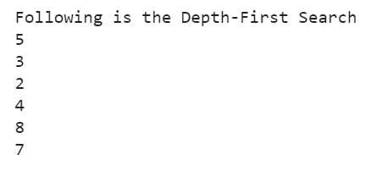

**TRACING:**

